
FMCS | Federal mediatiOn & conciliation service
OFFICE OF ARBITRATION

REQUESTOR’S USER GUIDE

Contents
OVERVIEW 2
REGISTER 2
LOGIN 3
LOGOUT 3
HOME 4
REQUEST ARBITRATION 4
MANAGE ACCOUNT 10
DEFAULT SELECTIONS 11
USER GUIDE 12
WHATS NEW 12
MANAGE A CASE 13
FAQs 17

OVERVIEW
A requestor is an internet user who publicly registers on the site and usually is a representative of a union or a company/other entity. As a requestor, you can submit a panel request on behalf of the parties involved in the dispute.

REGISTER
To gain access to the arbitration system you must first register.
- Click on Panel Requestor Registration link on the login page
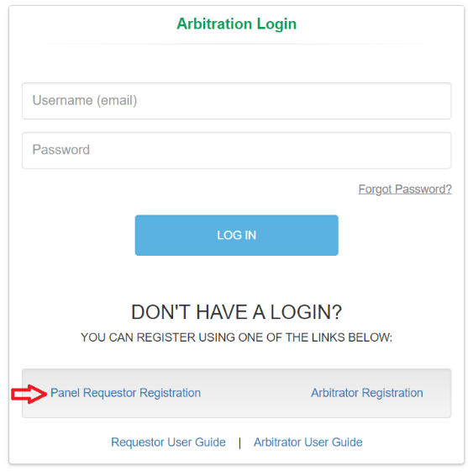
- On the Register Requestor window enter the required information, check “I’m not a robot” checkbox and click Register.
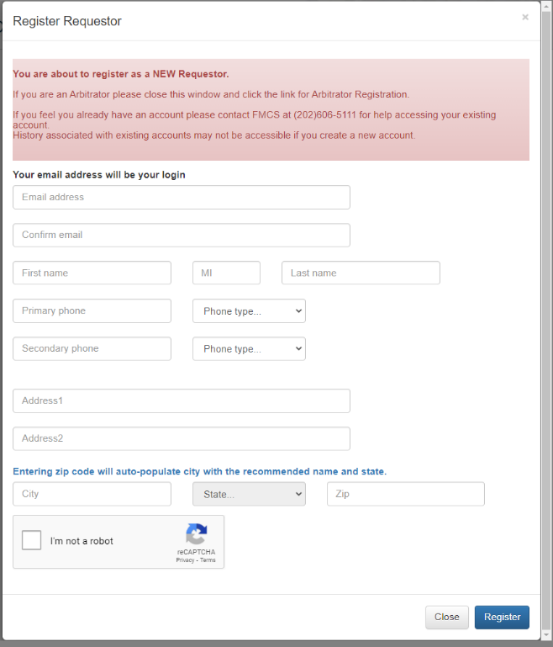
- A temporary password will be emailed to you at the email supplied during the registration process.
- When you login for the first time, you will be required to change your password.

LOGIN
To login to the arbitration system, you must already be a registered user.
- Enter your username and password on the login page and click the LOG IN button.
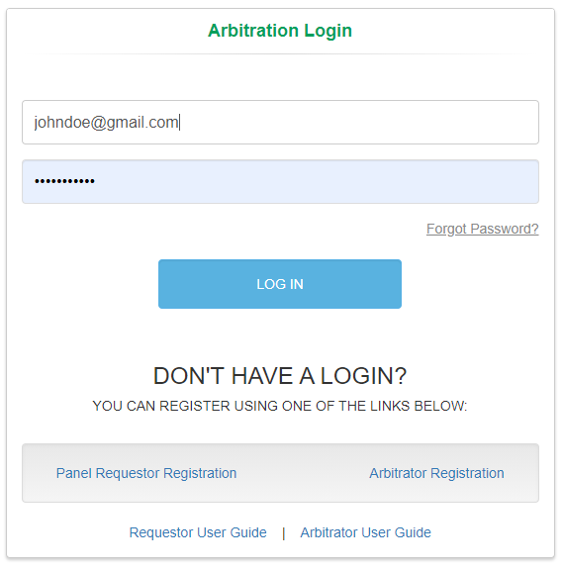
- If you have forgotten your password, click the Forgot Password Link on the login page. An email will be sent to the email address you enter with a new temporary password.
- When you login for the first time, you will be required to change your password.
- If you have any issues trying to log into the system or if you have already registered but do not remember your username, contact the FMCS Arbitration Staff at (202) 606-5111.

LOGOUT
To logout of the arbitration system, you should click the Logout button found at the top right of your screen. Clicking this button will help the system track when you have left.
The system will also automatically log you out after 20 minutes of inactivity. When this happens, you will be returned to the login page where a message will display saying that you have automatically been logged out due to inactivity.
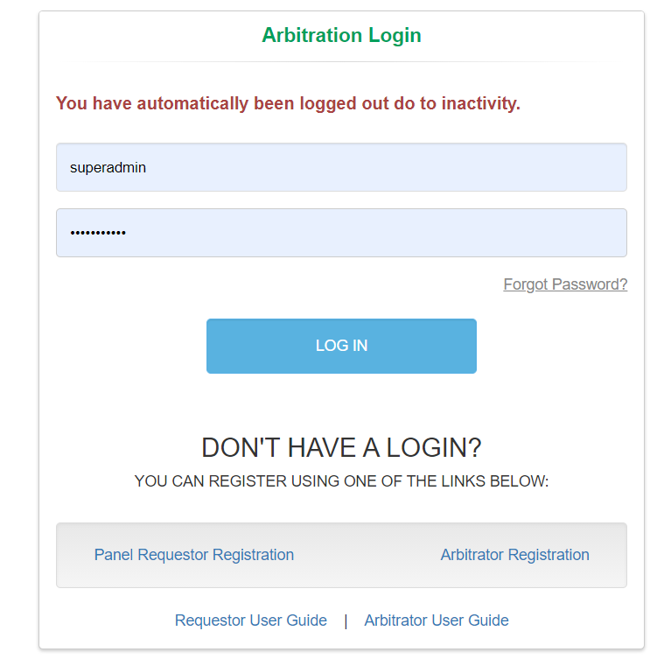

HOME
You can manage your cases via Home on the left navigation menu.
- Click Home in the left navigation menu. This will also be your default screen upon login.
- Two tabs display, Open Cases and Closed Cases. Cases that display on these tabs will be cases that you either requested or was listed as a representative.
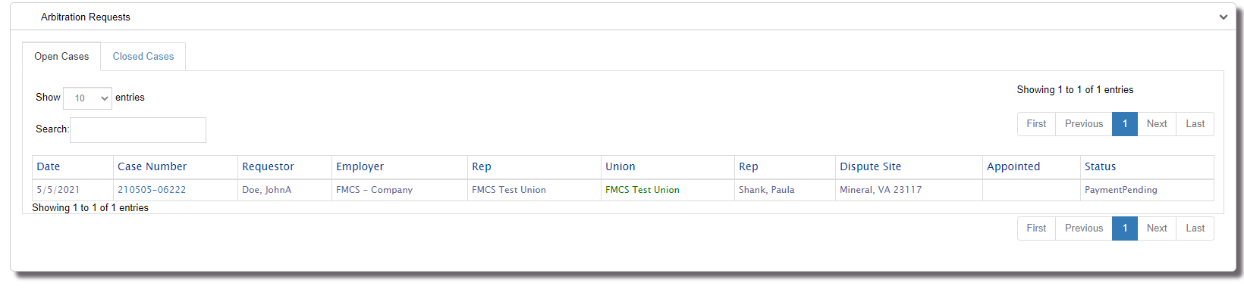
- Click the case number to manage the case. See Manage Cases section for more details.
- Hover over the Requestor to see the requestors affiliation.
- Hover over the Dispute Site to see the Dispute Issue.
- Hover over the Employer/Union to view the status of the Employer/Union if pending or on hold.

REQUEST ARBITRATION
Request Arbitration is where you would make a new panel request.

- Click Request Arbitration on the left navigation menu.
- Employer/Union Information tab: Select your affiliation, the Employer, Employer Representative, Union, and Union Representative.
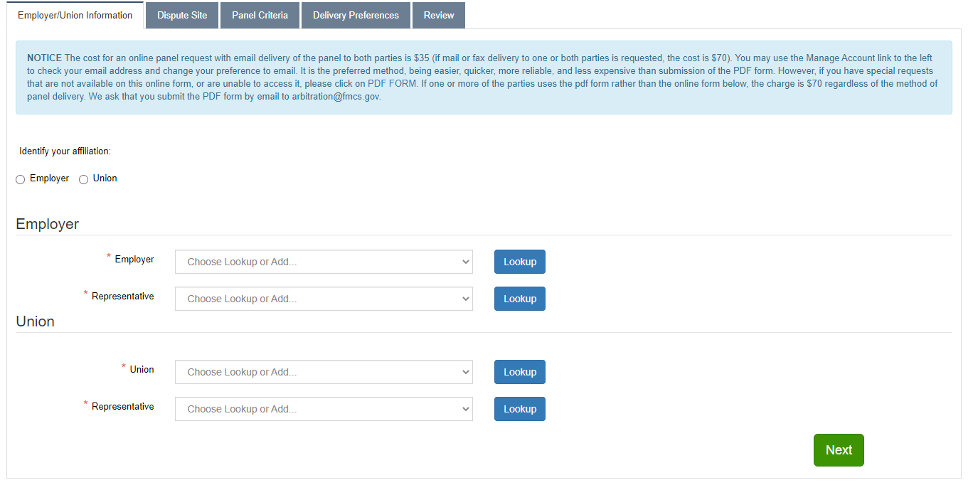
  - Click on the down arrow on the dropdown list and you will see a list of all your current default values that were entered under Defaults Selection on the left navigation menu or were entered on a prior Request for Arbitration. If your selection is available, click the value to select it.
  - Click the Lookup button to search for selections not in the dropdown list. From the search results you would click on the Name to make your selection. The window will close, and your selection will display in the dropdown list. If you have exhausted all your search options and need to add a new value, click the Add button and fill out all required information.
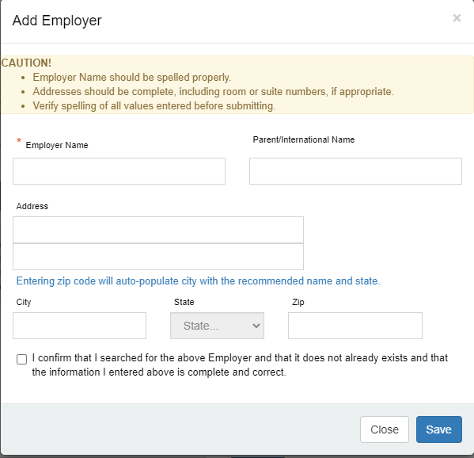
Clicking save will validate that your entry does not already exists. If a match is found, you will receive an alert.
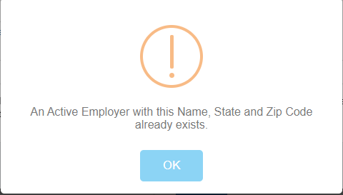
  - Click the Next button when you are done entering the required information.
- Dispute Site tab: Enter the following information.
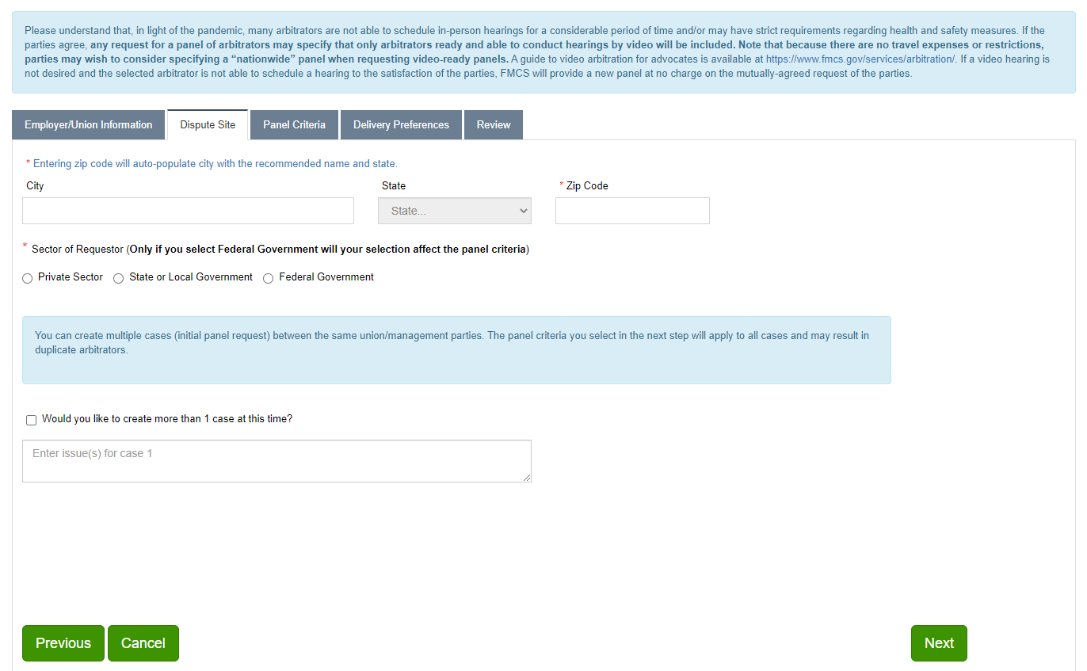
  - Dispute City, State and Zip Code. If you enter the zip code it will automatically enter the city and state for you.
  - Select the Sector for the Request
  - Enter the issue. You can create multiple cases between the same employer/union parties. The panel criteria you select on the next tab will apply to all cases. To create multiple cases, check the Would you like to create more than 1 case at this time checkbox. A dropdown list will display where you can select the number of issues you would like to enter up to 10. Based upon the number of issues you select in this dropdown list you will need to enter the same number of issues.
  - Click the Previous button if you need to return to the Employer/Union Information tab.
  - Click the Next button when you are done entering the required information.
  - Click the Cancel button when you need to cancel this request for arbitration. This will delete the request from the system.
- Panel Criteria tab: Enter the following information.
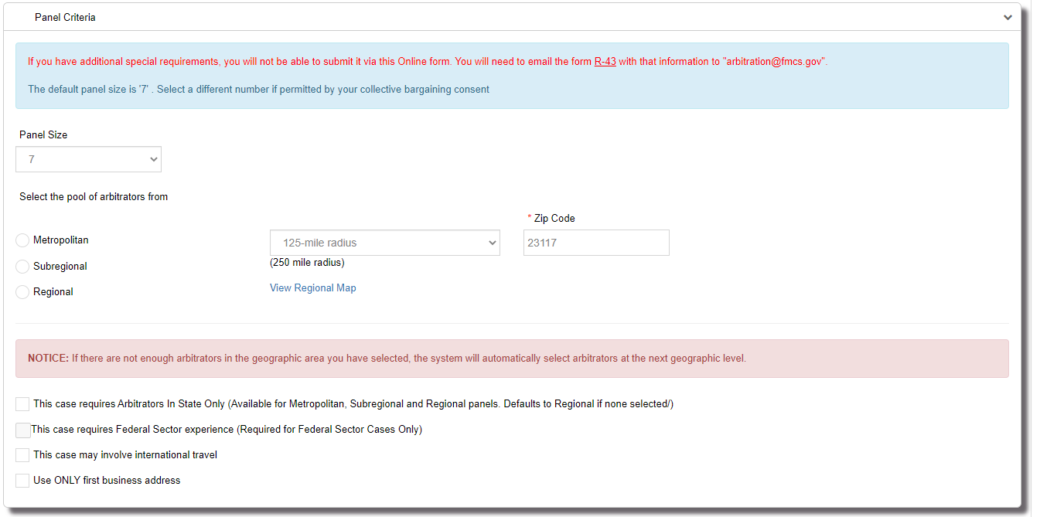
  - Panel Size. 7 is the default panel size but you can request anywhere between 5 and 15 arbitrators.
  - Select the pool of arbitrators from which you would like the panel to be generated from.
    - Metropolitan: Defaults to 125 miles from the dispute zip code but can be changed to 60 miles.
    - Sub regional: Defaults to 250 miles from the dispute zip code.
    - Regional: Defaults to the region of the dispute zip code.
    - If there are not enough arbitrators in the geographic area you have selected, the system will ask you if you would like to increase the geographical area. You will see a window pop up like this after you submit the request.
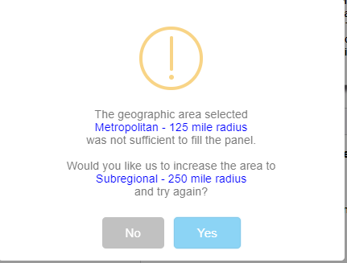
  - Checkbox: This case requires Arbitrators in State Only.
For each of the geographical areas depending on the radius you could end up with arbitrators from another state if they fall within the radius. Should you need a panel of arbitrators within the same state as the dispute zip code you would need to check this box.
  - Checkbox: This case requires Federal Sector Experience.
This checkbox will be automatically checked for Federal Sector cases. This field is disabled so you will not be able to uncheck this option.
  - Checkbox: This case may involve international travel.
Optional and should be checked if necessary.
  - Checkbox: Use ONLY first business address.
Optional and should be checked if necessary. This will pull arbitrators that meet the panel criteria and geographic area based upon their primary address only. When not checked it will look at all addresses an arbitrator is using.
  - Special Requirements section requires agreement from both parties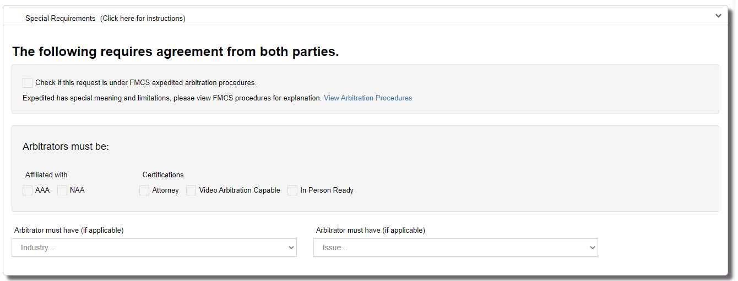
The optional fields here are.
    - Check if this request is under FMCS expedited arbitration procedures.
    - AAA
    - NAA
    - Attorney
    - Video Arbitration Capable
    - In Person Ready
    - Industry Experience. Only 1 industry selection is allowed.
    - Issue Experience. Only 1 issue selection is allowed.
    - When Next button is clicked you will see this window pop up if any special requirements were entered.
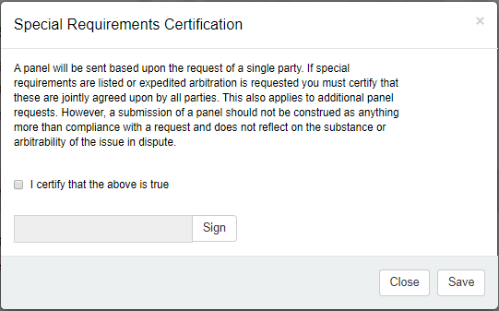
  - Click the Previous button if you need to return to the Dispute Site tab.
  - Click the Next button when you are done entering the required information.
  - Click the Cancel button when you need to cancel this request for arbitration. This will delete the request from the system.
- Delivery Preferences tab: Enter the following information.
  - Employer Contact Information. By default, the employer representative you selected on the Employer/Union Information tab will display. Changes made to this employer representative here will be reflected on all cases where this representative was selected.
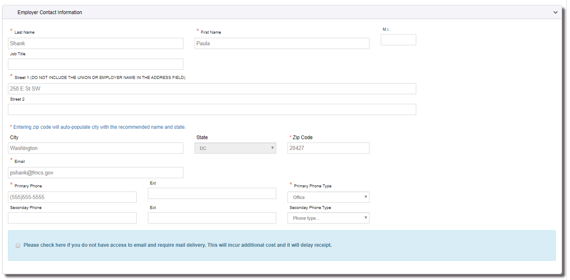
  - Union Contact Information. By default, the union representative you selected on the Employer/Union Information tab will display. Changes made to this union representative here will be reflected on all cases where this representative was selected.
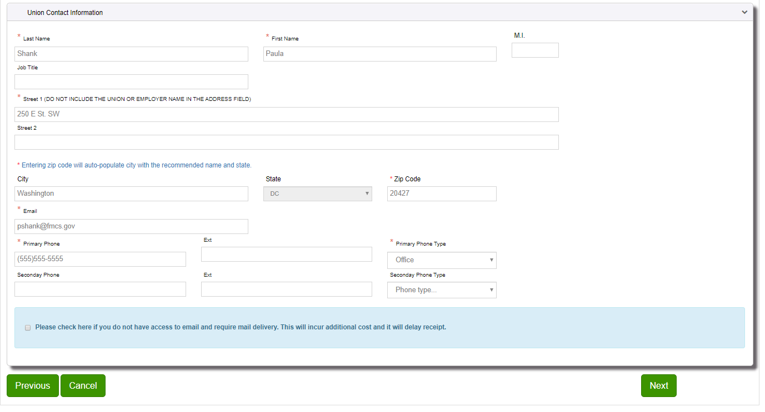
  - Click the Previous button if you need to return to the Dispute Site tab.
  - Click the Next button when you are done entering the required information.
  - Click the Cancel button when you need to cancel this request for arbitration. This will delete the request from the system.
- Review tab: Review and enter the following information.
  - Review your request carefully. FMCS is not responsible for your errors and will not re-issue panels because of errors made by the requestor. If anything is incorrect click the Previous button to return to the tab and make the necessary changes.
  - When you have finished reviewing your request Enter your Name and Phone Number than click the Submit button.
  - Once your request is submitted you will see a Congratulation window popup with the Case number(s) created that looks like this.
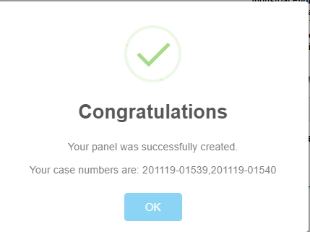
  - You will receive an email saying Case #xxxxx has been created.

MANAGE ACCOUNT
You can manage your account via Manage Account on the left navigation menu.
- Click Manage Account in the left navigation menu.
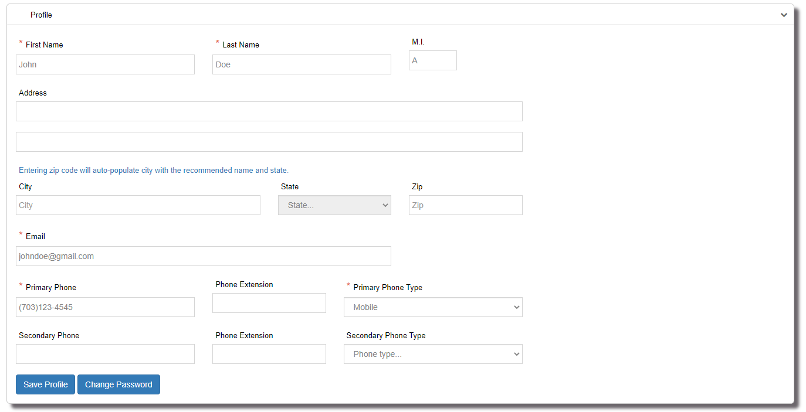
- Make all necessary changes to your account information and click the Save Profile button. If you also have representative records saving your profile will also update all active representative records.
- To change your password, click on the Change Password button. Enter your new password and click Submit button.
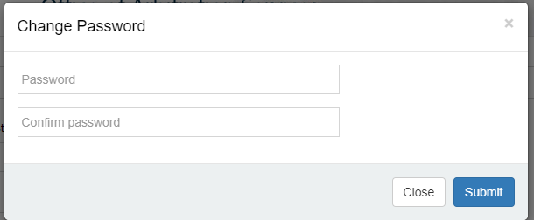
- Requestors may also be representatives. Representative records are linked to the requestors account by their email address. To view cases where you are a representative but did not request the panel your email address must be correct. At the bottom of Manage Account page your representative records will display. Profile changes will automatically update all active representative records.
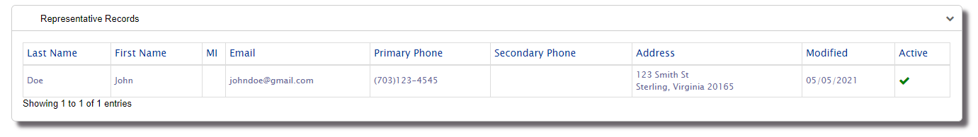

DEFAULT SELECTIONS
You can manage your default selections via Default Selections on the left navigation menu. Default selections is a mechanism whereby the arbitration system will store company/unions/representatives you have selected for previous panel requests. Upon further panel requests, the drop downs on the first step of the panel request process will be prepopulated with these selections. This can speed up the panel request process since you will not need to search for those selections every time. To manage these lists:
- Click Default Selections in the left navigation menu.
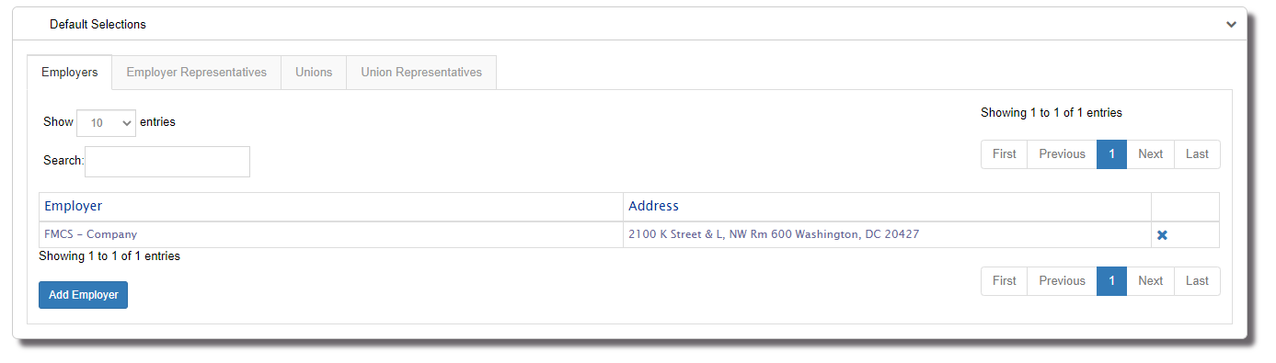
- Click on the tab to view your Employer, Employer Representative, Union, or Union Representative default selections.
- Click on the X button to remove and existing default selection.

- Click on the Add button to add additional default selections. A search window will display. Enter your search criteria and click the Search button. All matching results will display. To add one to your list, click on the value under Name. Once you are done adding all your default selections click the Close button.
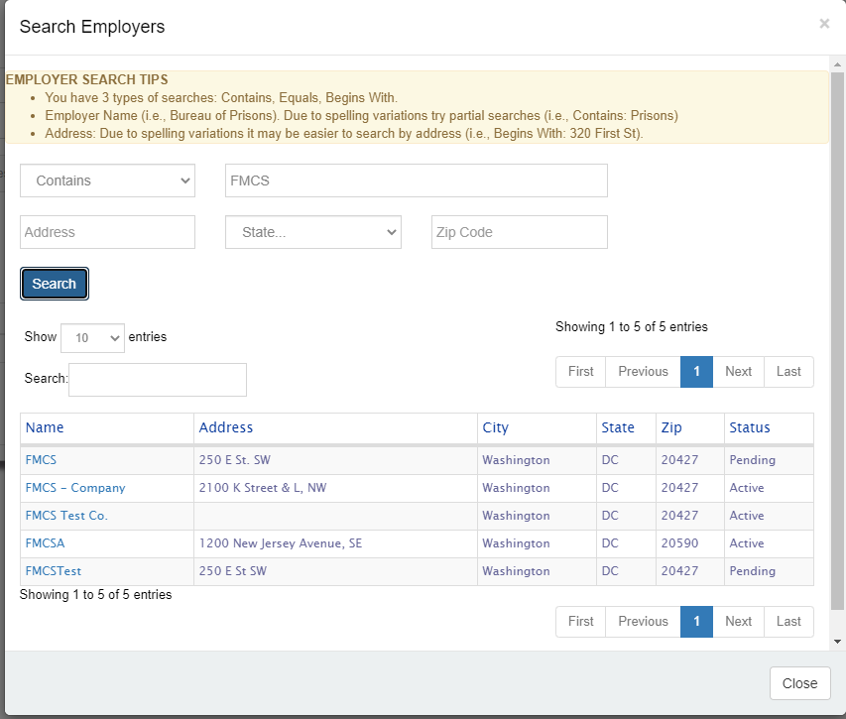
- All default selections added here will be available in the dropdown list when Requesting Arbitration.

USER GUIDE
Downloads the PDF version of the Requestor’s User Guide.

WHATS NEW
You can view details about recent changes to the Arbitration Application that relate to a requestor via What’s New on the left navigation menu.

MANAGE A CASE
You can manage a case by clicking a on case number via Home on the left navigation menu or after you submit a new request you will go directly to the screen where you can manage the case. Managing a case depend on the status of the case. Incomplete, Payment Pending and Open cases are all accessed from the Home pages Open Cases tab while all closed cases are accessed from the Home pages Closed Cases tab.
- Incomplete Cases
  - Click Complete Case button to complete the case you previously began.
  - Click Delete Case button to delete the incomplete case. It is recommended that if you incorrectly created a case instead of leaving it in the Incomplete state you delete the case.
- Payment Pending Cases
  - Click Make Panel Payment button to pay for the case.
    - Select your payment type.
      - Paygov Credit Card
      - Paygov ACH Checking
    - Fill in the required fields and click the Submit button. Once the panel has been successfully paid for all parties will receive the panel document (with arbitrator biographies attached) via email (if that was selected as the preferred contact method).
- Open Cases
  - Click Request Additional Panel button,
This will allow you the capability to request a new panel. See the Request Arbitration Section for more details. By default, it will start on the Panel Criteria tab since the case has already been created the Employer/Union Information and the Dispute Site information has already been set. By default, all criteria from the original panel will show as initial default values.
  - Click View Panel button
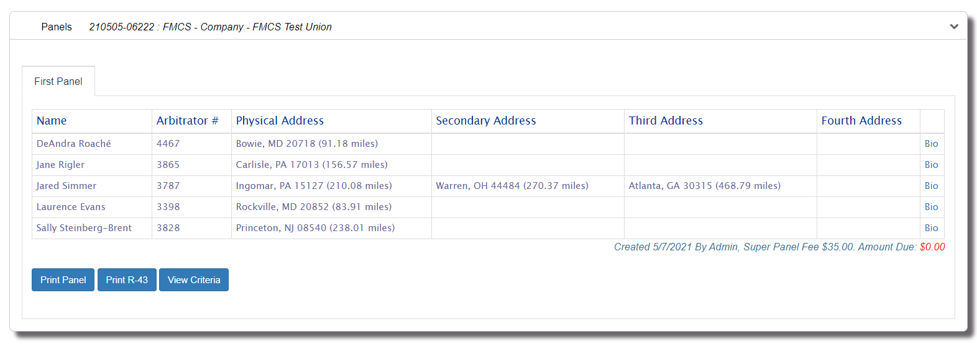
This will allow you the capability to view the panel details or take the following actions:
    - Bio link is listed for each arbitrator on the panel and will download the arbitrator’s digital biography as an Adobe Acrobat file(.pdf) which you can view and print.
    - Print Panel button will download the panel with bios for all arbitrators currently on the panels as an Adobe Acrobat file(.pdf) which you can view and print.
    - Print R-43 button will download the R-43 as an Adobe Acrobat file(.pdf) which you can view and print.
    - View Criteria will display all the criteria that was selected for this panel and used to pull the list of arbitrators.
    - Appointment History will display below the panel details showing any appointments associated with this case.
    - Payment History will display below the panel details showing any payment made against the panel displayed. Unlike the view case page that show all payments made against this case the payment history on the panel page will show only those payments made against the current panel. For cases with only one panel both locations will show the same information. While you will be able to see all payments and the amounts you will only be able to view the detail, print a receipt for payments that you have made.
  - Click Print R-43 button to download the R-43 as an Adobe Acrobat file (.pdf) which you can view and print.
  - Case Information Section
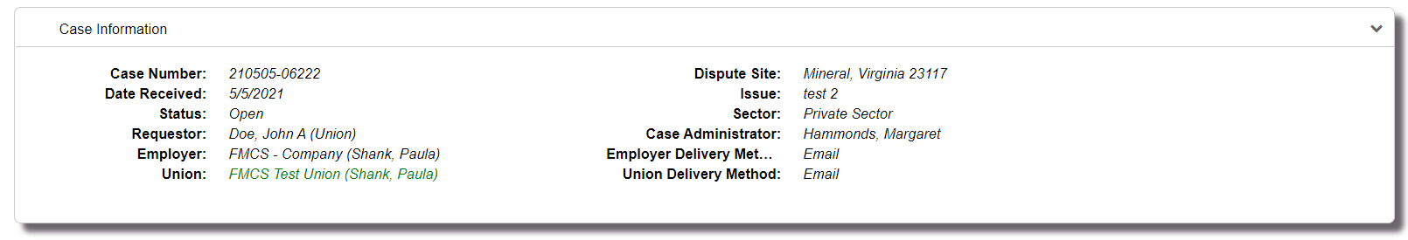This section will display the following details about the case.
    - Case Number
    - Date Received
    - Status
    - Requestor
    - Employer
    - Union
    - Dispute Site
    - Issue
    - Sector
    - Case Administrator
    - Employer Delivery Method
    - Union Delivery Method
  - Panel Criteria Section
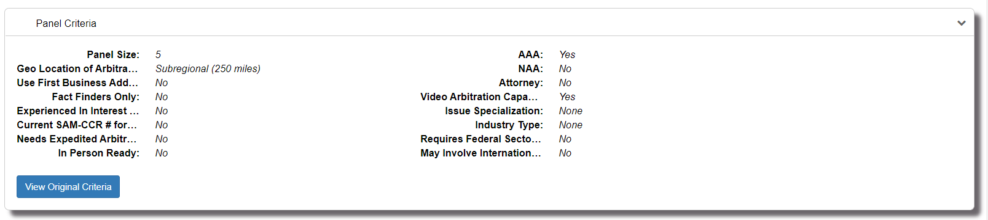
This section will display the latest panels criteria. For cases with multiple panels, you can click on the View Original Criteria button to view the original criteria entered for the 1st panel. In most cases where there is only one panel these will display the same details.
  - Case History Section
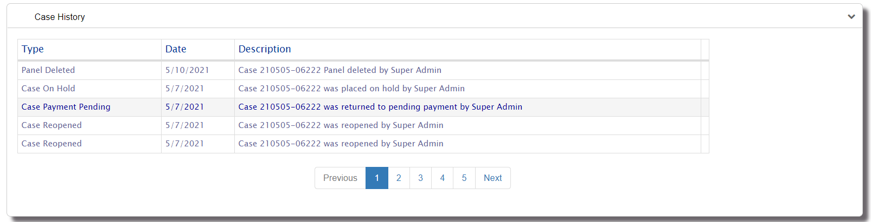
This section will display a list of actions taken for the case so far. It will display the type of action, what day the action took place and a description showing additional information along with who took the action.
  - Payment History Section
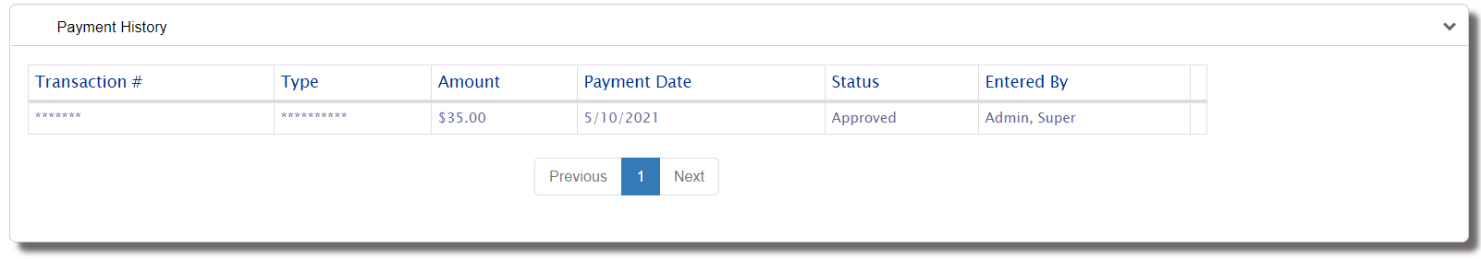
This section will show the payments that have been made for this case. While you will be able to see all payments and the amounts you will only be able to view the detail, print a receipt for payments that you have made. For cases with multiple panels this section will show all payments across all panels unlike the payment history section while viewing a specific panel that shows only the payments associated with that panel.
- Closed Cases
  - Cases that have been closed will contain one of the following closed statuses:
    - Awarded,
    - Settled/Withdrawn with No Fees,
    - Settled/Withdrawn with Fees
    - Settled After Hearing Began
  - Click Print R-43 button to download the R-43 as an Adobe Acrobat file (.pdf) which you can view and print.
  - Case Information Section
This section will display the following details about the case.
    - Case Number
    - Date Received
    - Status. In addition to showing the specific closed status it will also show the date the case was closed.
    - Requestor
    - Employer
    - Union
    - Dispute Site
    - Issue
    - Sector
    - Case Administrator
    - Employer Delivery Method
    - Union Delivery Method
    - Appointment will show the arbitrator that was appointed to the case.
  - Panel Criteria Section
This section will display the latest panels criteria. For cases with multiple panels, you can click on the View Original Criteria button to view the original criteria entered for the 1st panel. In most cases where there is only one panel these will display the same details.
  - Case History Section
This section will display a list of actions taken for the case so far. It will display the type of action, what day the action took place and a description showing additional information along with who took the action.
  - Payment History Section
This section will show the payments that have been made for this case. While you will be able to see all payments and the amounts you will only be able to view the detail, print a receipt for payments that you have made. For cases with multiple panels this section will show all payments across all panels unlike the payment history section while viewing a specific panel that shows only the payments associated with that panel.

FAQs

I registered for a new account or I clicked Forgot my password, but I did not receive an email.
Check your Junk/Spam folder. If you are running anti-virus, check your quarantine folder. Contact your IT department to investigate spam filters and/or firewalls to see if the email was identified as span and thus never delivered. Contact the FMCS Arbitration Staff at (202) 606-5111 to confirm that you have the correct email address in the system and if they can confirm if the email was sent or bounced back.

My email address has changed; I am no longer able to log into the system or I would prefer to log in using my new email address.
The system is still using your old email address as its login. You should log in with your old email address and then go to Manage Accounts where you can update your email. This will change only your email so that you will receive all necessary correspondence. Your login would remain as your old email. Should you like your login to be synced up with your new email you will need to contact the FMCS Arbitration Staff at (202) 606-5111 and ask them to sync up your login with your new email. It is important that you do not create a new account with your new email address because your old requests will not show for your new email/login.

If you have already created a new account do not worry, contact the FMCS Arbitration Staff at (202) 606-5111. If you have not yet started any arbitration requests the FMCS Staff can easily delete this new account. You would then update your email as stated above and ask the FMCS Staff to sync up your login to your new email address.

If you have already entered a request under this new account let the FMCS Staff know so that they can then merge your accounts together.

I am not seeing all my requests, specifically the ones where I am a representative.
When you log in on your home page you will see all requests that you requested or that you are a representative for. The link is your email address so if you are not seeing cases where you are a representative most likely your representative email address associated with the case has an old or bad email address. Contact the FMCS Arbitration Staff at (202) 606-5111. Let them know the case number and any old email address that you may have used as a representative that needs to be updated.

How do I remove a request I accidentally made?
Incomplete and Payment Pending cases can be deleted from the system. On your Home page go to the Opened Cases tab. Click on the case number. At the top of the page, you should see a Delete Case button. Click this button and then click Yes on the confirmation window. Your case will be deleted from the system. Please note there will be no way to get this case back once you have confirmed that you would like to delete it.

How do I request a 2nd panel?
On your Home page go to the Opened Cases tab. Click on the case number for which you would like to create a 2nd panel. At the top of the page, you should see a Request Additional Panel button. If you are not seeing the case, see the FAQ for “I am not seeing all my requests….” above.

