
FMCS | FEDERAL MEDIATION & CONCILIATION SERVICE
OFFICE OF ARBITRATION

ARBITRATOR’S USER GUIDE

Table of Contents
OVERVIEW 2
REGISTER 2
LOGIN 3
LOGOUT 3
HOME 4
AVAILABILITY 6
AREA RESTRICTIONS 7
EMPLOYER/UNION RESTRICTIONS 8
MANAGE ACCOUNT 9
MANAGE BIOGRAPHY 10
ISSUE EXPERIENCE 14
INDUSTRY EXPERIENCE 14
WHATS NEW 15
PAY ANNUAL DUES 15
R-19 INFORMATION 16
FAQs 19

OVERVIEW
An arbitrator is an internet user who publicly registers on the site, submitted an application and has been accepted to the roster.

REGISTER
To gain access to the arbitration system you must first register.
- Click on Arbitrator Registration link on the login page
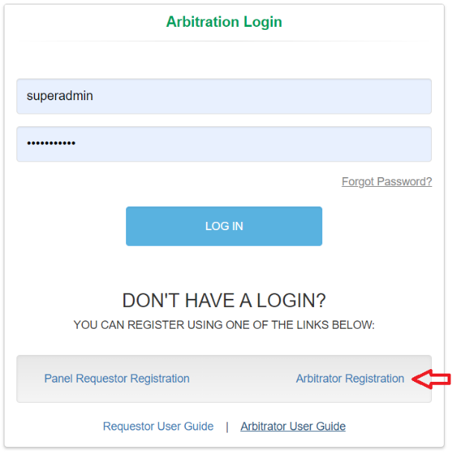
- On the Register Arbitrator window enter the required information, check “I’m not a robot” checkbox and click Register.
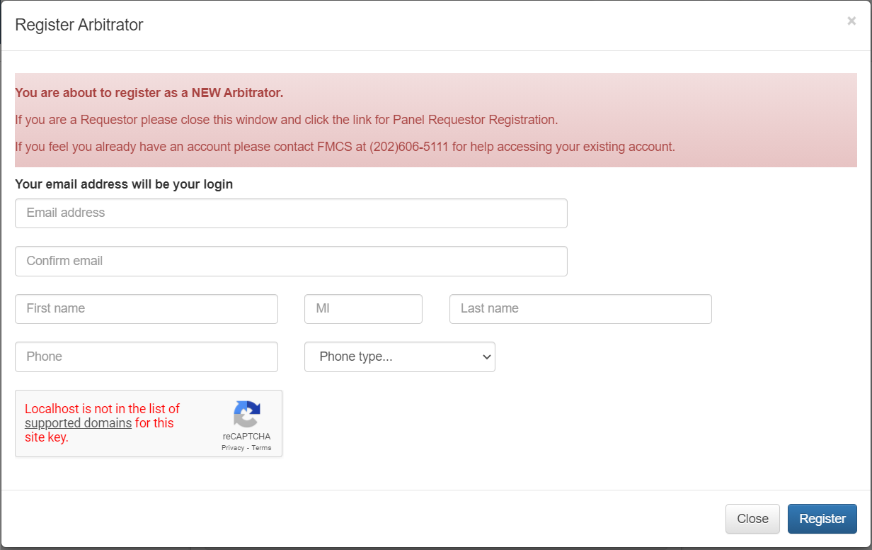
- A temporary password will be emailed to you at the email supplied during the registration process.
- When you login for the first time, you will be required to change your password.

LOGIN
To login to the arbitration system, you must already be a registered user.
- Enter your username and password on the login page and click the LOG IN button.
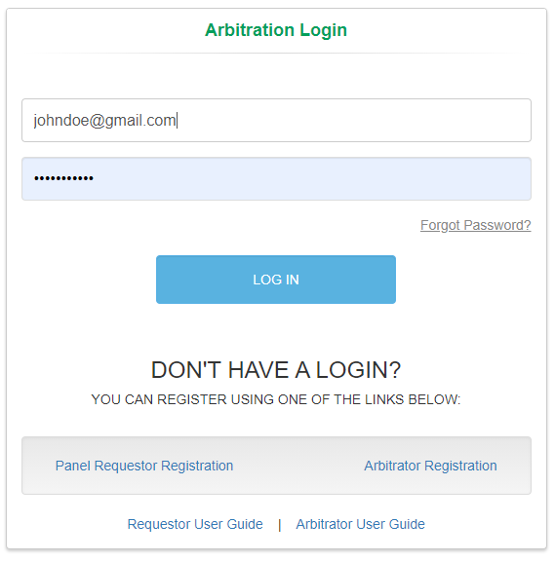
- If you have forgotten your password, click the Forgot Password Link on the login page. An email will be sent to the email address you enter with a new temporary password.
- When you login for the first time, you will be required to change your password.
- If you have any issues trying to log into the system or if you have already registered but do not remember your username, contact the FMCS Arbitration Staff at (202) 606-5111.
- If you have not yet submitted your application and been accepted onto the roster, please see the Arbitrator Applicant User Manual for further details.

LOGOUT
To logout of the arbitration system, you should click the Logout button found at the top right of your screen. Clicking this button will help the system track when you have left.
The system will also automatically log you out after 20 minutes of inactivity. When this happens, you will be returned to the login page where a message will display saying that you have automatically been logged out due to inactivity.
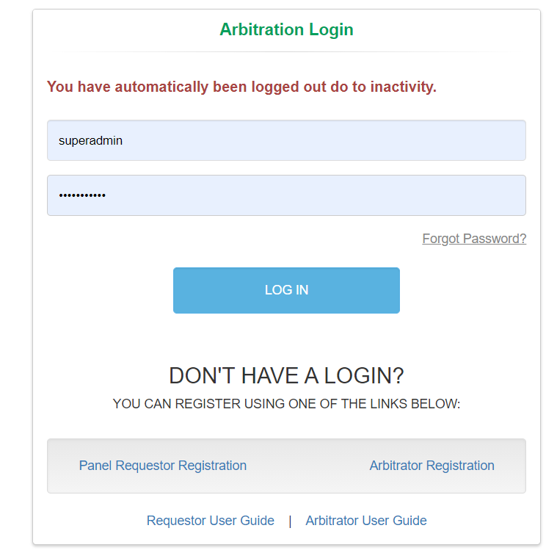

HOME
You can manage your cases for which you have been appointed via Home on the left navigation menu.
- Click Home in the left navigation menu. This will also be your default screen upon login.
  - At the top of your page, you may see a list Arbitrator Alerts. These are messages and actions that need to be completed. Please make sure to read these messages as some of the actions may be required to be considered for future panel selection.
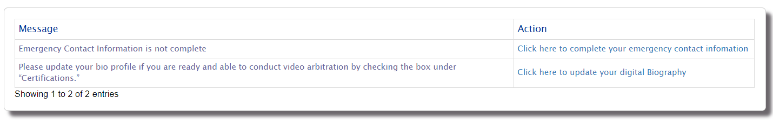
  - Click on the Open Appointed Cases tab to view all cases you have been appointed to that have not yet been closed.
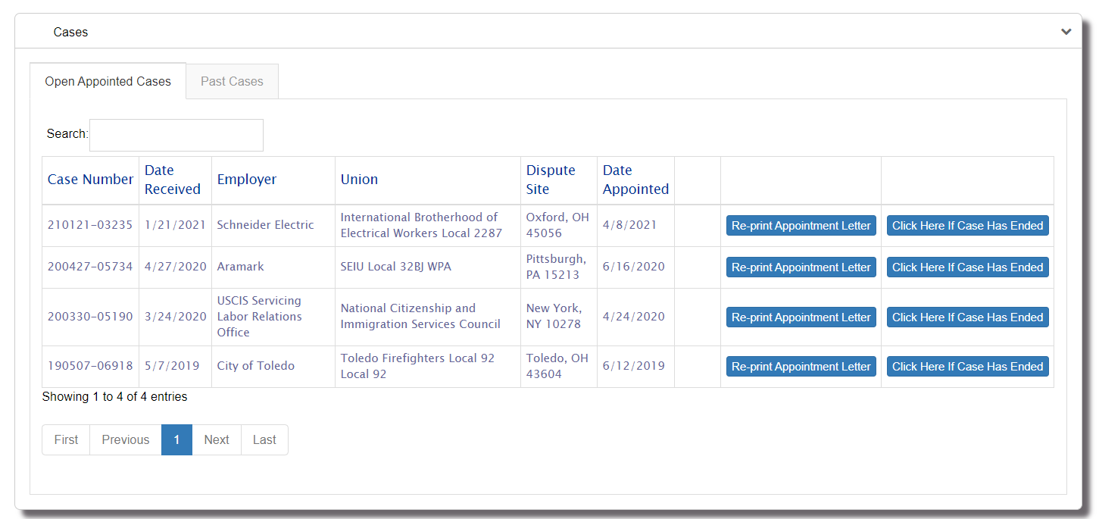
    - Video Camera icon may be visible to the right of the Date Appointed.
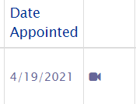
This icon means that the case requested arbitrators that were Video Arbitration capable. The appointment letter you received should also reflect this by showing number “*parties requested a panel of arbitrators who were video ready” after the case number.
    - Click on the Re-print Appointment Letter button if you did not receive your appointment letter, you were unable to open the attachment in the email or if you just need to print a new copy. You should have received the appointment letter on the date you were appointed to the case. If you did not receive the email you may want to check your Junk/Spam folder and confirm that your email address is correct in the system.
    - Click the Click here if Case Has Ended button to close the case. You will be prompted with the following question.
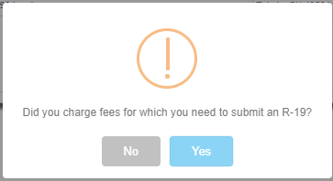
    - NO: You will be prompted to confirm you want to end the case
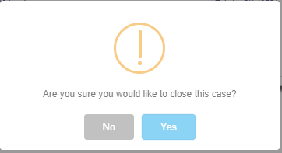
      - NO: Processing will be canceled
      - YES: Case will be ended with a status of Settled/Withdrawn with No Fees. The case will move from the Open Appointed Cases tab to the Past Cases tab.
    - YES: You will be required to enter your R-19 information. See the section on R-19 for information about filling out this form.
  - Click on the Past Cases tab to view all cases you have been appointed to that have already been closed. No actions can be taken on this tab.
    - Hover over the Status to view the Disposition date.
    - Hover over the R-19 Submitted message to view the Date of Report.

AVAILABILITY
You can manage the dates for which you would not like to be considered for panel selection via Availability on the left navigation menu.
- Click on the Availability link in the left navigation menu.
- Enter the start and end dates for the range of time you would like to be unavailable for panel selection and click Submit. You will now be excluded as a potential arbitrator for any panels created during this period.
- View your history of unavailability dates. For future dates you will have the capability to delete the entry. You will not be ability to delete dates that have passed as the system may have already excluded you from panels during those dates.
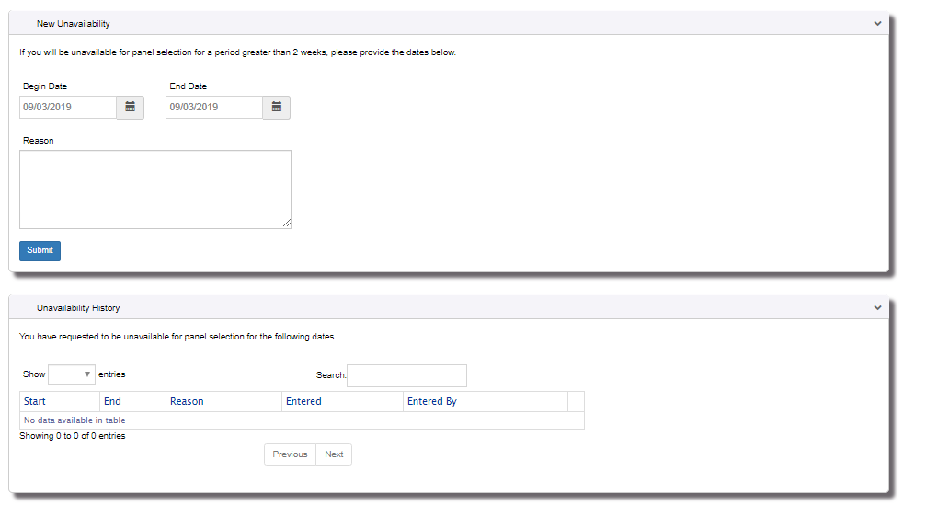

AREA RESTRICTIONS
You can manage the geographic areas for which you would not like to be considered for panel selection via Area Restrictions on the left navigation menu.
- Click on the Area Restrictions link in the left navigation menu.
- Zip Code Inclusions allow you the capability to enter 2 zip codes and the radius around each of these zip codes for which you would only like to be considered for panels. Note that the radius is a direct path from the zip code and does not take road distance into consideration. When entering zip code inclusions there is no need to exclude any regions or states.
- Region Restrictions allow you the capability to check the regions for which you would like to be excluded from panel consideration.
- State Restrictions allow you the capability to check the states for which you would like to be excluded from panel consideration.
- NOTE: Updates to area restrictions do not change panels that you have already been considered for. Only panels going forward will look at these new restrictions. So, if on Jan 1 you are placed on a panel in Virginia and on Jan 2 you check Virginia under State Restriction you will still be on the panel created on Jan 1 and may be appointed to that panel
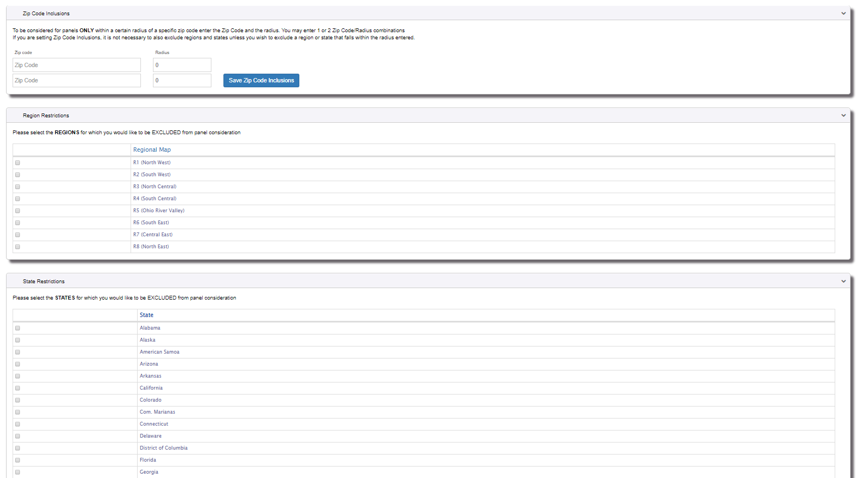

EMPLOYER/UNION RESTRICTIONS
You can manage the Employers and Unions for which you would not like to be considered for panel selection via Employer/Union Restrictions on the left navigation menu.
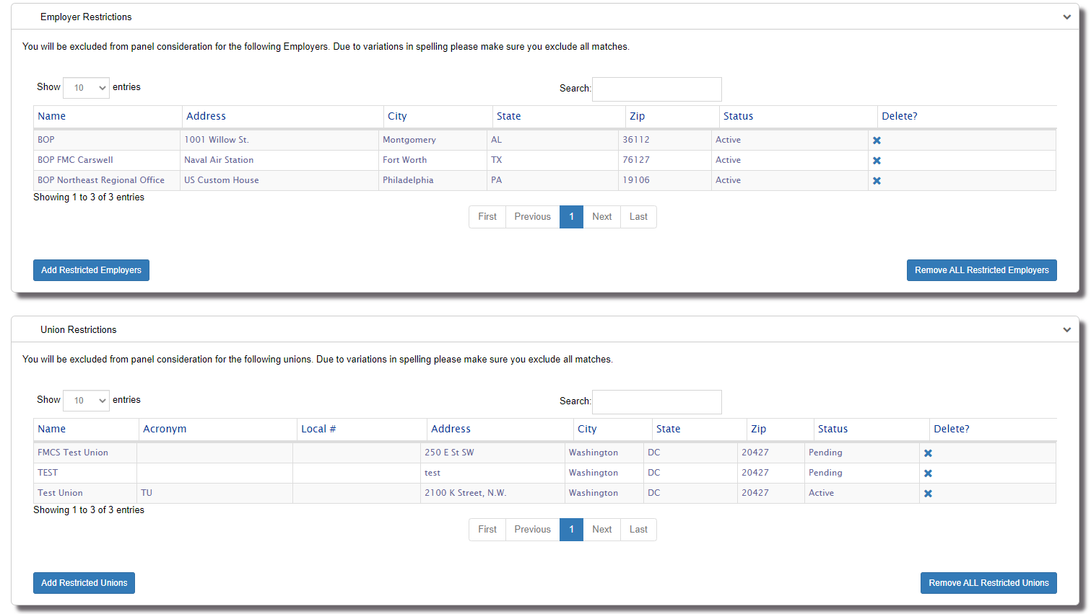
- Click on the Employer/Union Restrictions link in the left navigation menu.
- Click the X to delete an individual Employer/Union or click the Remove ALL Restricted Employers/ Remove ALL Restricted Unions to remove items from the Restricted list.
- Click the Add Restricted Employers/Add Restricted Unions button to search for an employer or union. Select the items in the search results list to be added to the restrictions list and click Add to Restricted.
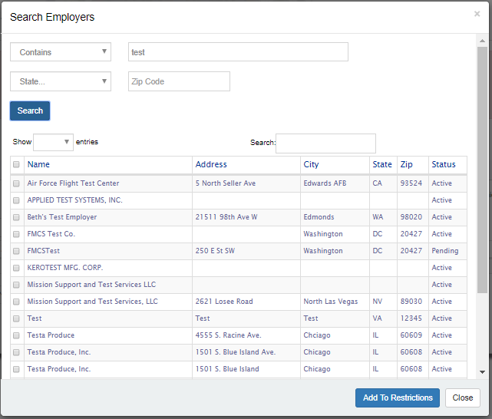
- NOTE: The Employer and Union lists are huge and there are many duplicates. If you are trying to restrict yourself from all Bureau of Prisons you would need to perform multiple search (Bureau of Prisons, BOP etc.) You would need to add all results to your restricted list.

MANAGE ACCOUNT
You can manage your account via Manage Account on the left navigation menu.
- Click on the Manage Account link the left navigation menu.
- Make all necessary changes to your account information and click the Save button. Emergency Contact information fields are now required. Changes to your email address will only change your email. Your current login will remain the same. Should you like your login to be synced up with your new email you will need to contact the FMCS Arbitration Staff at (202) 606-5111 and ask them to sync up your login with your new email.
- To change your password, click on the Change Password button. Enter your new password and click Submit button.
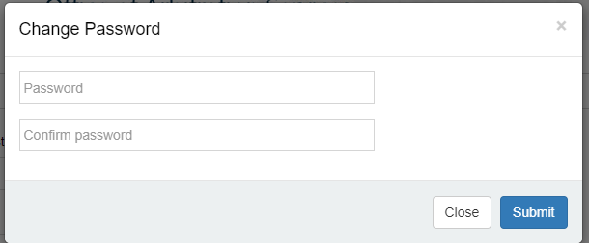
- To view your original application, click on the View Application button. For older arbitrators, a PDF version of their original application will display. For arbitrators who completed their application online a digitally version of their application submitted will be generated and displayed in PDF format.
- Payment History will display all your prior payments.
  - Click the Date to view the payment details.
  - Click Print Receipt to print the payment receipt.
  - Payment Receipts are for Annual Dues and Additional Address payments.
- View FMCS letter previously sent to you.
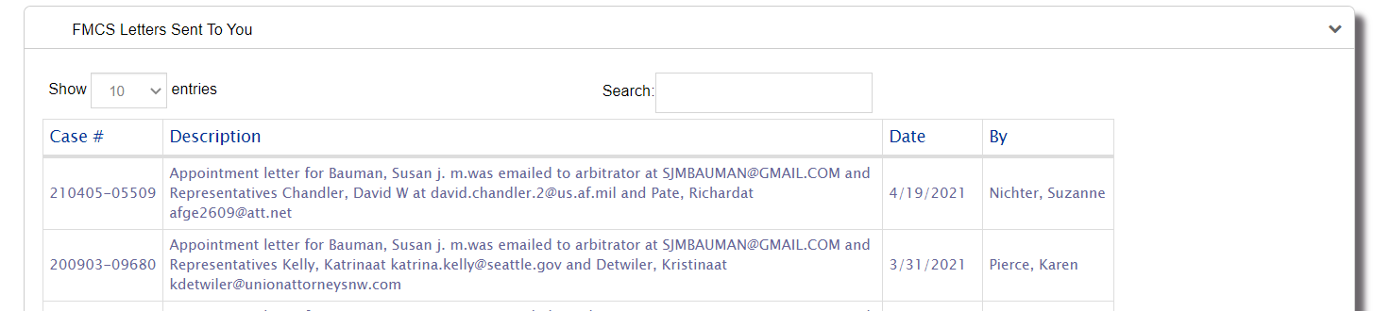

MANAGE BIOGRAPHY
You can manage your digital biography via Manage Biography on the left navigation menu.
- Click on the Manage Biography link in the left navigation menu.
- Manager Profile and Biography Section will contain your primary address and any additional addresses that have been paid for. The address zip codes that are paid for will be used in determining what panels you are eligible to be considered for. Click the Save Biography button or link to save your updates. Your digital biography will be updated with the updated information.
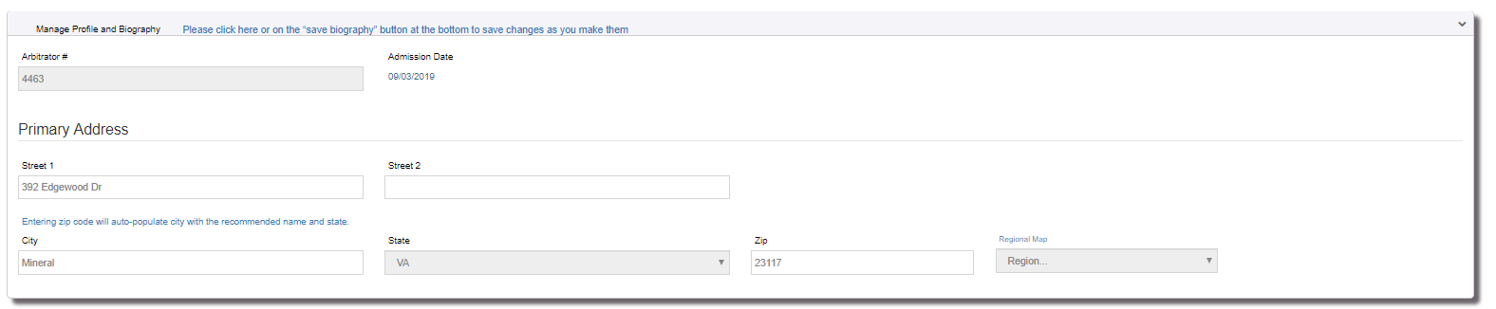
- Profile Details Section contains information that is used to determine what panels you are eligible to be considered for. Check all options that pertain to your experience and skill set. You may optionally choose to create a professional statement of up to 500 characters. An example of what it might look like is as follows:
“Over twenty years of experience in labor-management relations, including grievance arbitration, fact-finding, and collective bargaining negotiations. Formerly, administrative law judge with the Department of the Redundancy Department, hearing a variety of benefits claims. Have served on many tripartite panels, conducted numerous expedited arbitration hearings, and gained substantial experience in interest arbitration. I am an Eagle Scout.”
Note: For federal Sector cases you must have federal sector experience to be considered for Federal Sector cases.
Click the Save Biography button or link to save your updates. Your digital biography will be updated with your updated information.
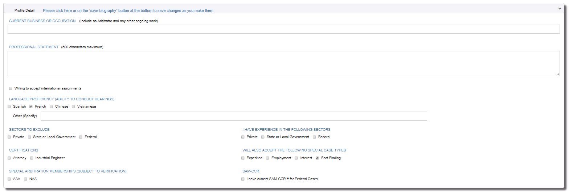
- Education/Certification/Affiliation Section
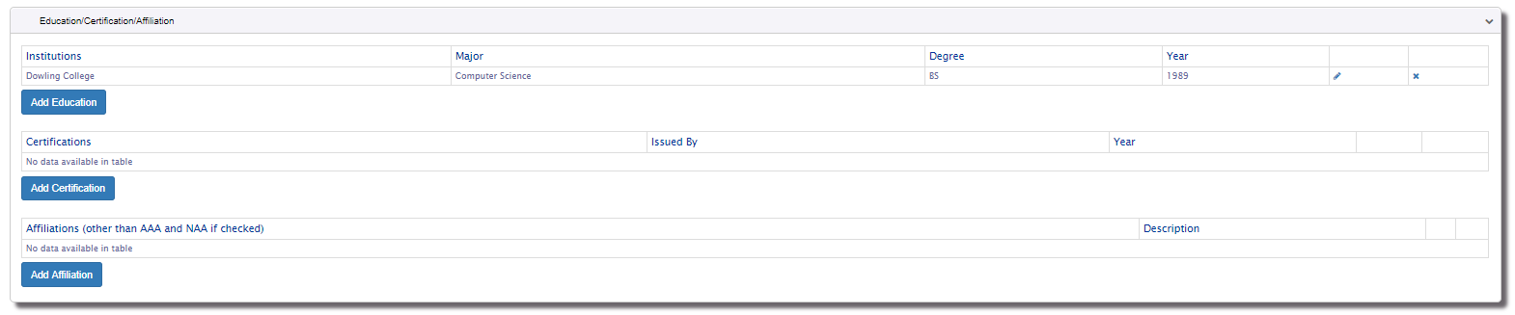
  - Education allows you to enter up to 7 institutions. It is suggested that you enter your most recent or most relevant education.
  - Certification allows you to enter up to 10 certifications. It is suggested that you enter your most recent or most relevant certifications.
  - Affiliation allows you to enter up to 10 affiliations. It is suggested that you enter your most recent or most relevant certifications. AAA and NAA will automatically be included on your digital biography if you checked them in the Profile Details section so there is no need to add them to the Affiliation section.
  - Click the Add Educations, Add Certification and Add Affiliation buttons to add new information. A corresponding window will open where you will be required to enter the new information you would like to add.
  - Click the Edit Icon ( ) to edit existing information.
  - Click Delete Icon () to delete existing information.
  - Information added, edited, or deleted is updated automatically. Your digital biography will be updated with your updated information.
- Labor Management Relations Experience Section
  - Employers allows you to enter up to 10 employers. It is suggested that you enter your most recent or most relevant employers.
  - Click the Add Experience button to add new information.
  - Click the Edit Icon ( ) to edit existing information.
  - Click Delete Icon () to delete existing information.
  - Information added, edited, or deleted is updated automatically. Your digital biography will be updated with your updated information.
- Associations section
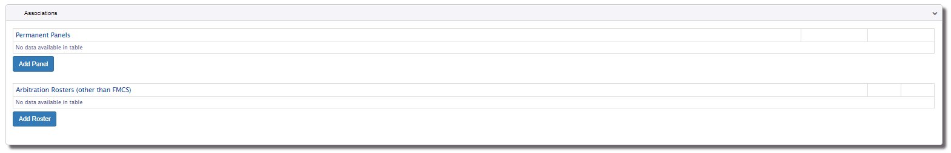
  - Permanent Panels allows you to enter up to 20 Permanent Panels. It is suggested that you enter your most recent or most relevant permanent panels.
  - Arbitration Roster allows you to enter up to 15 Permanent Panels. It is suggested that you enter your most recent or most relevant Rosters. FMCS will automatically be included on your digital biography so there is no need to add it as an Arbitration Roster.
  - Click the Add Panel, Add Roster button to add new information.
  - Click the Edit Icon ( ) to edit existing information.
  - Click Delete Icon () to delete existing information.
  - Information added, edited, or deleted is updated automatically. Your digital biography will be updated with your updated information.
- Published Cases section
This information will be saved when you click the Save Biography button or link. Your digital biography will be updated with your updated information. You are limited to 1500 characters maximum. Once you have reached the 1500th character you will no longer be able to type. It is recommended that you enter your most recent or most relevant published cases. You may also look for ways to abbreviate should you have more than 1500 characters.
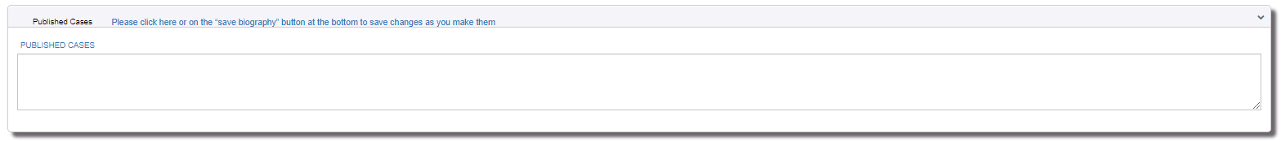
- Fees & Policies section
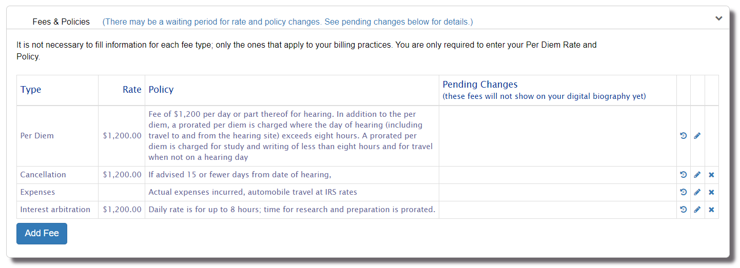
  - There are multiple Fee Types that you can select from. The fee type other is currently the only fee type that is allowed more than once.
    - Per Diem is required and cannot be deleted.
    - Cancellation
    - Expenses
    - Interest Arbitration
    - Air Transportation
    - Travel Time
    - Interest on Past Due Payments
    - Other
  - Click the Add Fee button to add new a new fee type. Only available fee types will display in the dropdown list. Some fee types have a waiting period. A message will display below the selected fee type letting you know if there is a fee type and when the new rate will take effect.
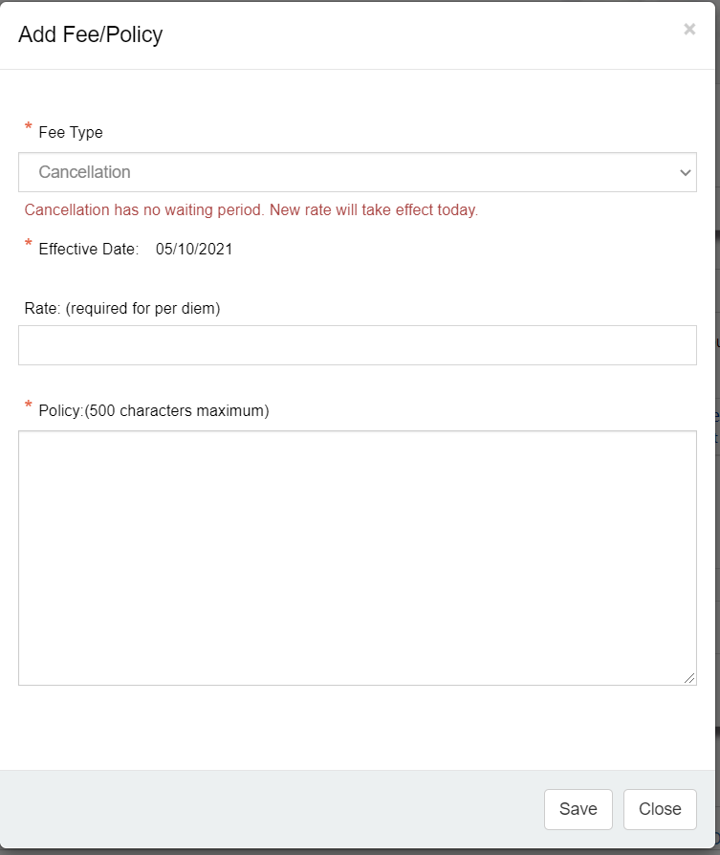
  - Click the Edit Icon ( ) to edit existing information. If the fee type that you are editing has a waiting period a message will show telling you went the rate change will take effect. For example, changes to your per diem have a 30 day waiting period before they will take effect and appear on your digital bio.
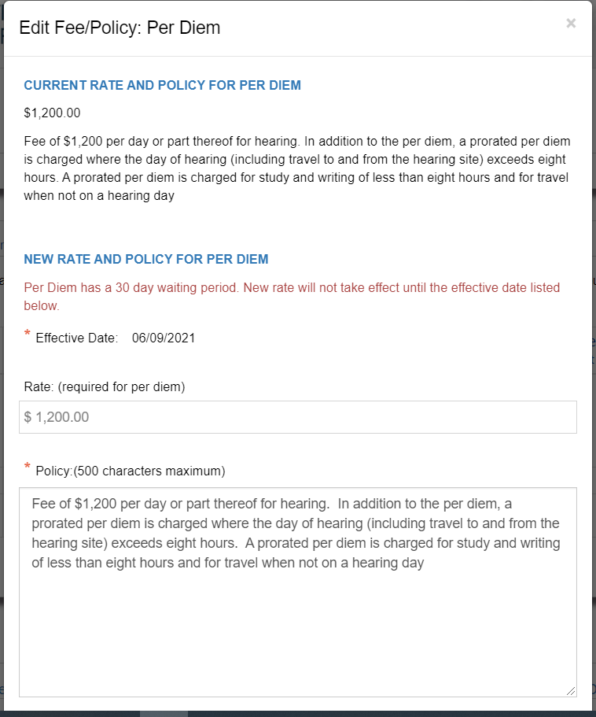
  - Click Delete Icon () to delete existing information. All fee types except for Per Diem can be deleted.
  - Information added, edited, or deleted is updated automatically. Your digital biography will be updated with your updated information.
- Biography File section
  - Click the Download Bio button to view your digital biography. It is important to download and view your digital biography to ensure it contains all your information. Follow any of the above steps to make additional changes and download your biography until it looks the way you want it to look when it goes out on panels.
- Save Biography Button. There are several save biography links throughout the page in addition to this button that will save all your changes made to your biography. These save pertain to all information entered on this main page. Information entered on windows that open after you click Add or Edit are saved at that time. If you are unsure just click the Save button or link to make sure you do not lose any changes.

ISSUE EXPERIENCE
You can manage your Issue Experience via Issue Experience on the left navigation menu.
- Click on the Issue Experience link in the left navigation menu.
- Make any appropriate changes to your issue experience by checking the appropriate radio button of 0, 1-4 or 5+ years’ experience and click the Save button.
- Your digital biography will be updated with your updated information.
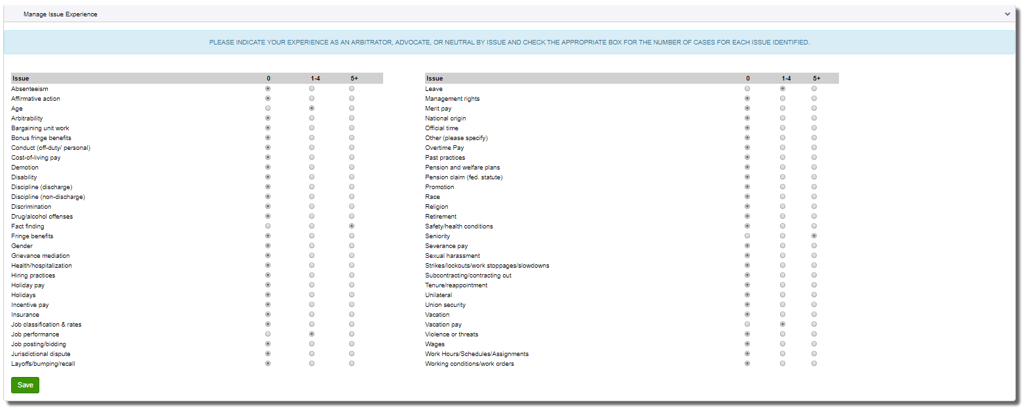

INDUSTRY EXPERIENCE
- You can manage your Industry Experience via Industry Experience on the left navigation menu.
- Click on the Industry Experience link in the left navigation menu.
- Make any appropriate changes to your industry experience by checking the appropriate radio button of 0, 1-4 or 5+ years’ experience and click the Save button.
- Your digital biography will be updated with your updated
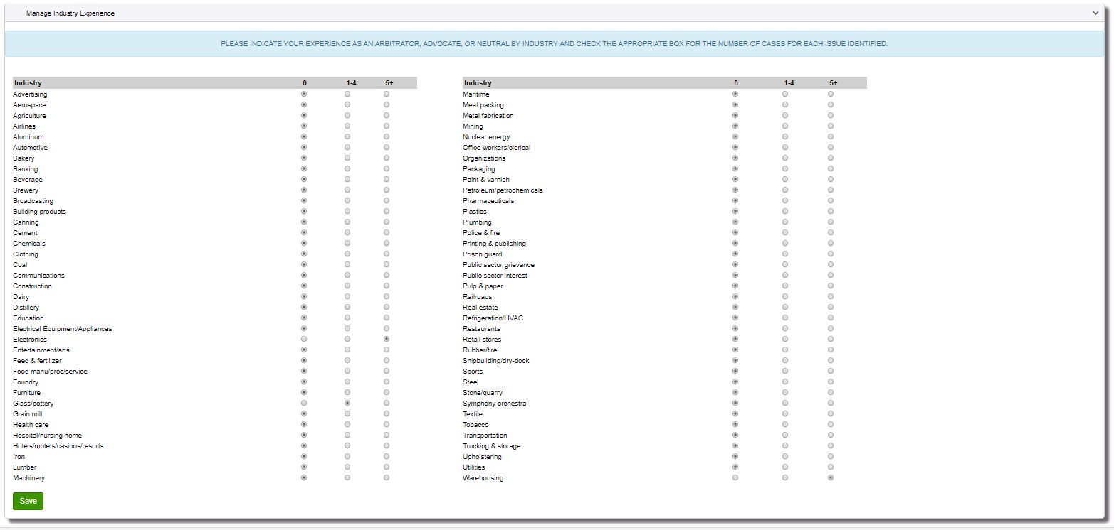

WHATS NEW
You can view details about recent changes to the Arbitration Application that relate to an arbitrator via What’s New on the left navigation menu.

PAY ANNUAL DUES
To pay your annual dues to remain on the FMCS roster of arbitrators:
- On July 1 you will receive an email that your annual dues are due by September 30th. You will see the notification to pay your annual dues at the top of each page.
- Click on the Pay Annual Dues button to go to the annual dues’ payment page. The annual dues cost for primary address and additional addresses will display in the blue box.
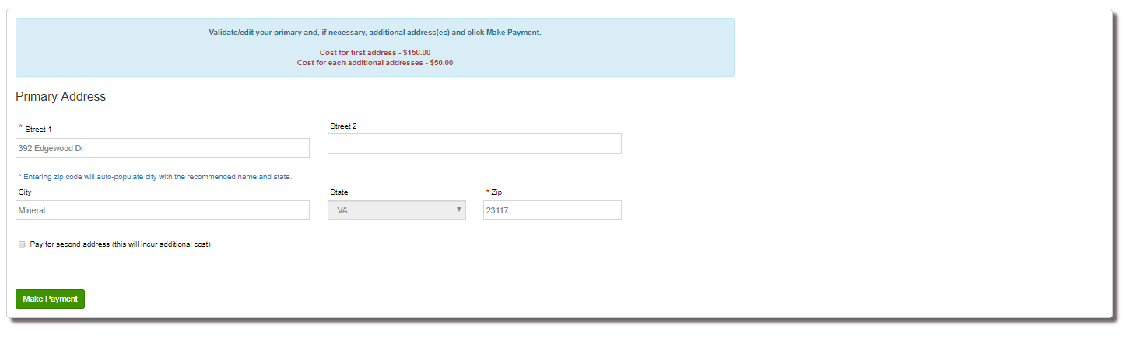

- Enter/edit your primary address.
- Alternatively, you can pay for additional addressed by checking the box to pay for 2nd, 3rd, 4th address. Upon checking the box, the additional address fields will display so that you can enter the information.
- Click the Make Payment button to complete the payment with Pay.Gov. The amount you owe will automatically be calculated based upon how many addresses you have entered.
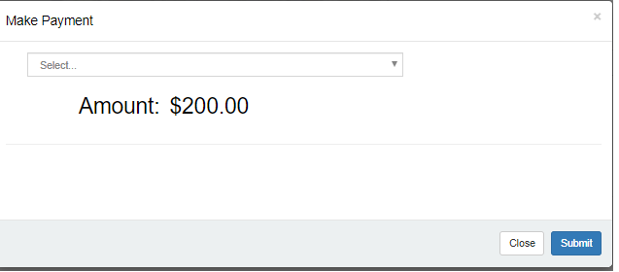
- Once you have paid you will be available for panel selection. If you have not paid you will continue to receive an email reminder on August 1 and September 1. On October 1 you will be unavailable for panel selection due to non-payment.

R-19 INFORMATION
To enter R-19 information you must click the Click Here if Case Has Ended button on your home pages Open Appointed Cases tab.
- Case Information section will be prepopulated with the case number, Arbitrator Name, Employer and Union. 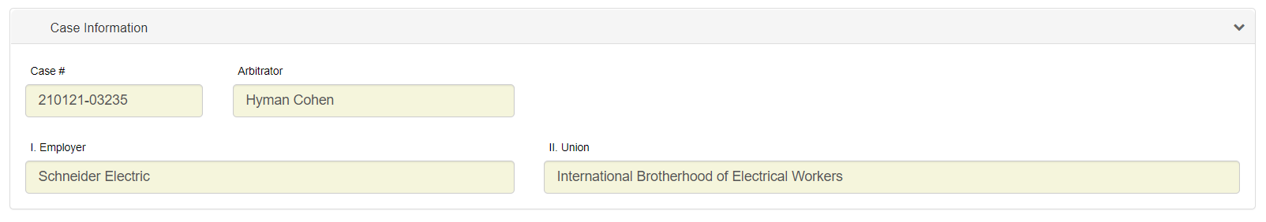
- Award Information section. You will only need to enter the Date of Award if an award was made.
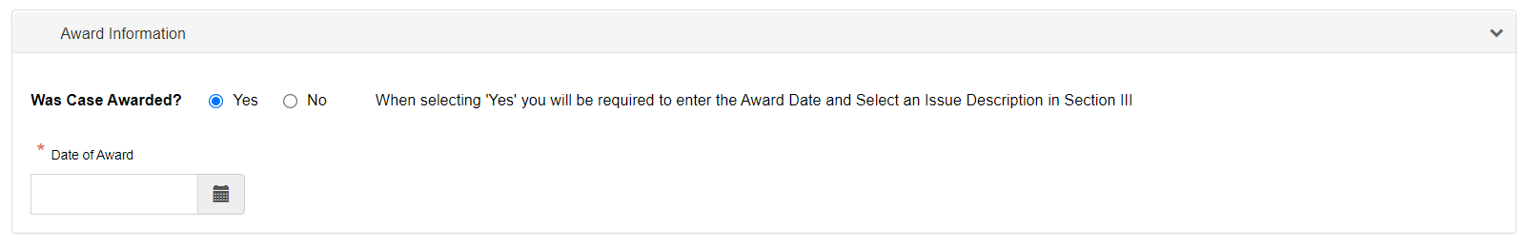
- Issues section will be prepopulated with some defaults
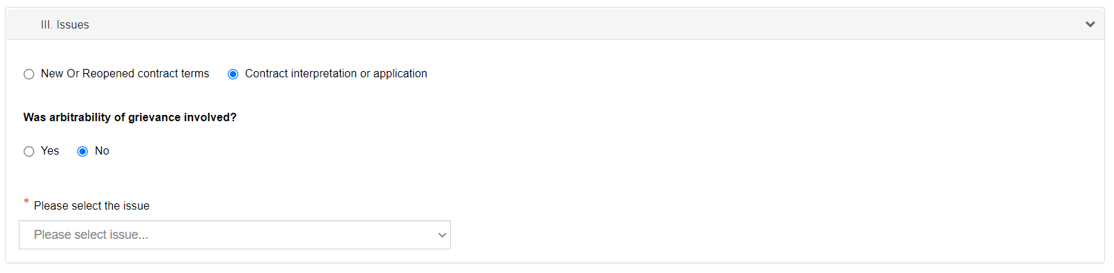
  - Contract Interpretation or application will be selected with the option to change it to New or Reopened contract terms.
  - Was arbitrability of grievance involved will default to No with the option to change it to Yes. Should you change it to yes you will be asked if it is Procedural or Substantive. You will be required to check at least one.
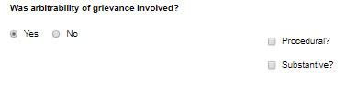
  - A dropdown list of issues will be available to selected from. You will only need to select an issue if an award was made or if canceled but there was at least one hearing day.
- Hearing Information section will be prepopulated with some defaults.
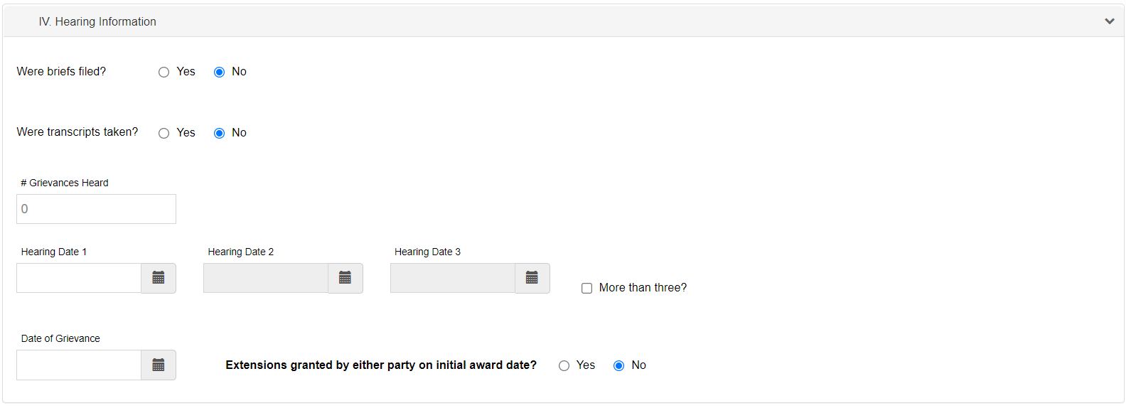
  - Were briefs files will default to No with the option to change it to yes. When changed to yes, a date control will display for you to enter the date the briefs were filed.
  - Were transcripts take will default to No with the option to change it to yes.
  - Enter the number of grievances heard along with the hearing dates.
  - Enter the date of Grievance.
  - Extension granted will default to No with the option to change it to yes.
- Fees and Days for Service section will be prepopulated with some defaults.
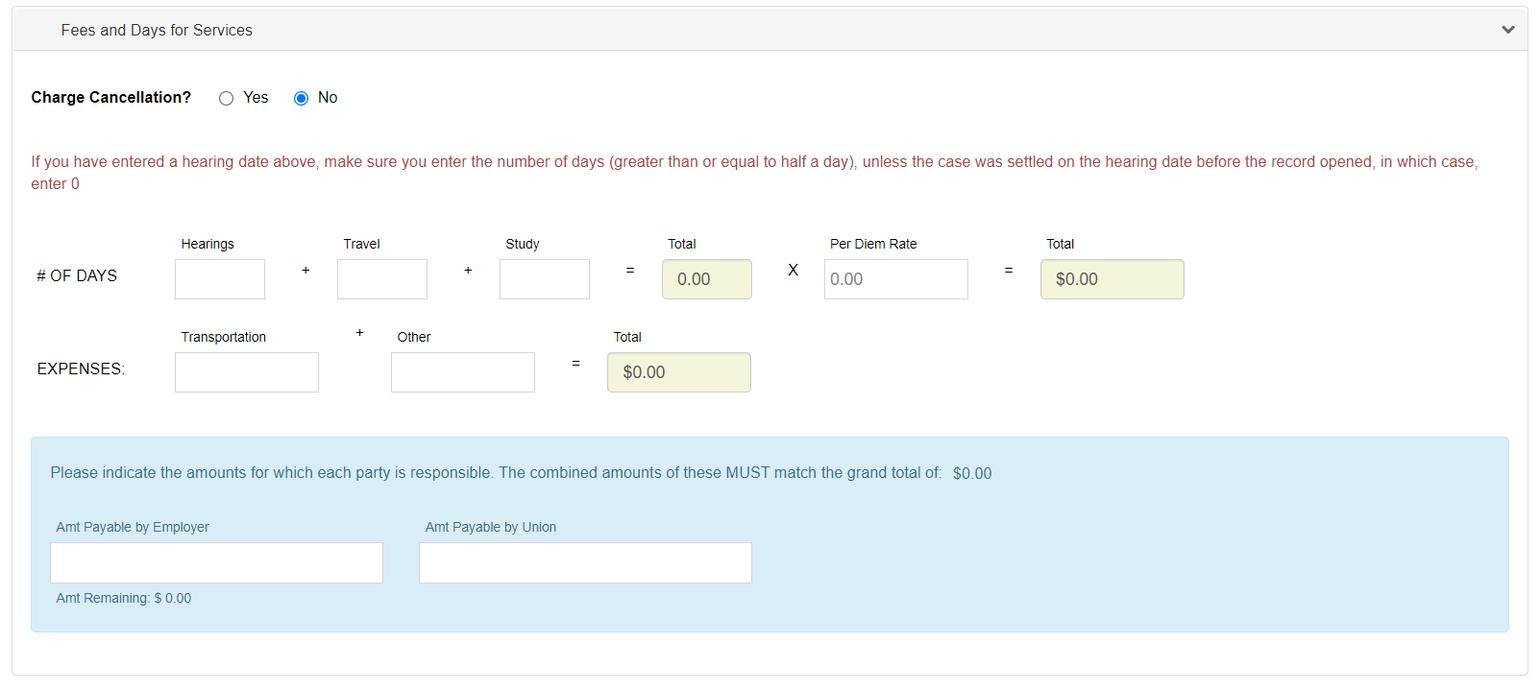
  - Charge Cancellation will default to No but can be changed to yes. When changed to yes, a fee control will display for you to enter the charges associated with the cancellation.
  - # of days allows you to enter the number of Hearing Days, Travel Days and Study Days. The total number of days will automatically be calculated and displayed. Enter your per diem rate and the total cost will automatically be calculated. To enter 2 days, you would type in 200 so that the number of days displays as 2.00. To enter 2 ½ days you would type in 250 so that the number of days displays as 2.50. Similarly, for the per diem rate you would enter for example 125000 for it to show as $1,250.00.
  - Expenses allows you to enter the additional cost charged for transportation and other expenses. The total expenses will automatically be calculated.
  - Once you have entered in all the number of days and cost the amount shown in the blue box will be updated with the total cost. At this point you would enter how much the employer and union are each responsible for.
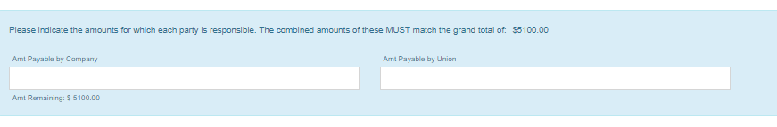

- Final section will be prepopulated with some defaults.
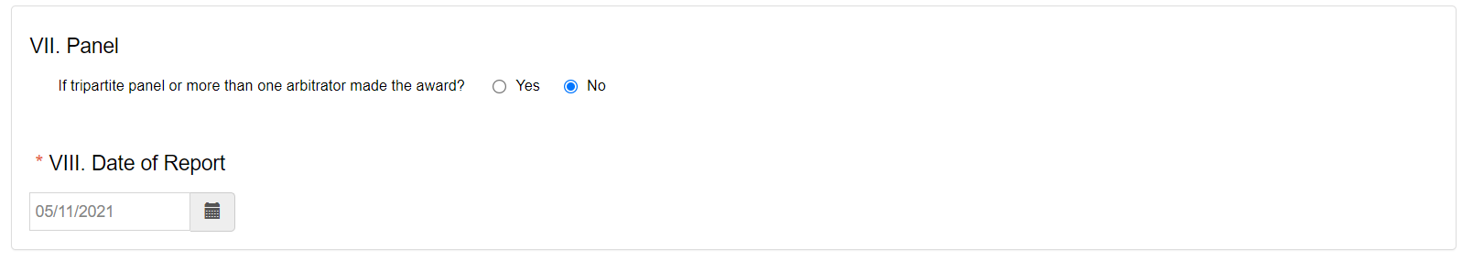
  - If tripartite panel or more than one arbitrator made the award will default to no but can be changed to yes.
  - Enter the date of report. This field is required.
- Click the Submit button to submit your R-19 information.
  - Validation will run an if issues were found a red message will display next to the field. For example, if you said the case was awarded but did not enter an Award date you would see this.
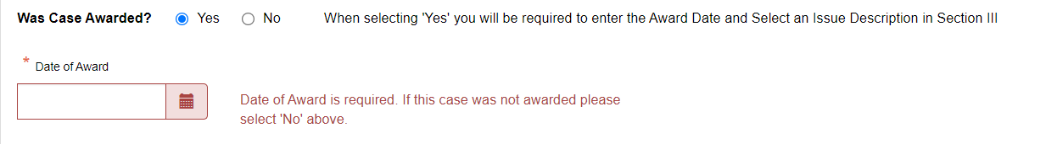
  - If the amount payable by the employer and the union do not equal the total cost, you will be prompted with the following.
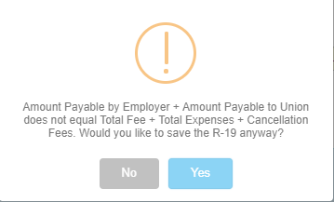
If you click no you will return to the R-19 page so that you can correct your amounts. If you click yes or if the amounts had been correct initially the case will be closed with the status of Settled/Withdrawn with Fees or Awarded depending on the R-19 data entered. The case will move from the Open Appointed Cases tab to the Past Cases tab.

FAQs

I registered for a new account or I clicked Forgot my password, but I did not receive an email.
Check your Junk/Spam folder. If you are running anti-virus, check your quarantine folder. Contact your IT department to investigate spam filters and/or firewalls to see if the email was identified as span and thus never delivered. Contact the FMCS Arbitration Staff at (202) 606-5111 to confirm that you have the correct email address in the system and if they can confirm if the email was sent or bounced back.

My email address has changed; I am no longer able to log into the system or I would prefer to log in using my new email address.
The system is still using your old email address as its login. You should log in with your old email address and then go to Manage Accounts where you can update your email. This will change only your email so that you will receive all necessary correspondence. Your login would remain as your old email. Should you like your login to be synced up with your new email you will need to contact the FMCS Arbitration Staff at (202) 606-5111 and ask them to sync up your login with your new email. It is important that you do not create a new account with your new email address. Doing so would require you to fill out and submit a new application to be accepted to the roster which is not necessary if you are already on the roster.

If you have already created a new account do not worry, contact the FMCS Arbitration Staff at (202) 606-5111. They can remove the new account and help you regain access to your original account.

I never received my appointment email.
Check your Junk/Spam folder. If you are running anti-virus, check your quarantine folder. Contact your IT department to investigate spam filters and/or firewalls to see if the email was identified as span and thus never delivered. Go to Manager Account and make sure your email address is correct. In some cases, it may not be the same as your login. Contact the FMCS Arbitration Staff at (202) 606- 5111 to see if they can confirm if the email was sent or bounced back. In the meantime, you can click the Re-print Appointment Letter on your home page Open Appointed Cases tab so that you have a copy of the appointment letter.

I restricted myself from Union ABC so why was I appointed to a panel for Union ABC?
When you add in restrictions it is from that point forward. Previously generated panels which occurs before the data you are appointed to the case do not look at new restrictions. If on Jan 2, you restricted yourself from Union ABC you may still have been placed on a panel for Union ABC on Jan 1 which you were just appointed too today. Another reason may be that you have not restricted yourself from all versions of Union ABC. The union tables may have duplicates due to multiple spelling so it important that you restrict all version, or it would be possible to still be considered for a panel for Union ABC. For example, you would want to add to your restriction list “Union ABC”, “Union A B C”, “Unionabc”, “ABC Union” etc.

I am going to be unavailable for the next month what do I need to do so that I am not considered for any new panels during this time.
No need to contact the FMCS Arbitration Staff to make you inactive and then call them back at the end of the month to make you active again. You can take care of this by clicking Availability on the left menu. Enter the dates you will be unavailable an at the end of the period you will automatically be considered for panel selection again.

I do not think I am being considered for panels.
Being considered for panels and being appointed are 2 different things. Currently you are only able to see the panels that you have been appointed to. Panels will consider you for all panels where you meet the criteria and will use all addresses that you have paid for. You will be placed on the panel or considered as an alternate on a panel. The parties than make the appointment. Some things to look at first.
- Make sure you have not said you were not available by clicking on Availability on the left navigation menu.
- Make sure you have not restricted yourself from regions or states incorrectly by clicking on Area Restrictions on the left navigation menu. Also make sure you have not set a zip code and radius incorrectly.
- Make sure your biography looks good and has all the information correct by clicking on Manage Biography on the left navigation menu. Although there are only a few make sure you have completed your digital biography. If your digital biography is not complete you will not be considered for any panels. You will see warning stating that your digital biography is not complete and at this time there are only a few arbitrators that have not done this.

