
FMCS | FEDERAL MEDIATION & CONCILIATION SERVICE
OFFICE OF ARBITRATION

ARBITRATOR APPLICANT USERS GUIDE

Table of Contents
OVERVIEW 2
REGISTER 2
LOGIN 3
LOGOUT 3
HOME 4
APPLICATION 4
STEP 1: Biographical Information 5
STEP 2: Education, Certifications, and Professional Memberships. 6
STEP 3: Labor-Management Relations Experience, Union Involvement and Government positions 7
STEP 4: Permanent Panels and Arbitration Rosters 8
STEP 5: Issue Experience 9
STEP 6: Industry Experience 10
STEP 7: Sector Experience, Registration, Language Proficiency and Arbitration Experience 11
STEP 8: Federal Sector Experience and Fees Charged 12
STEP 9: Award Citations, Publications and Date Available 13
STEP 10: Certification of Advocacy and Accuracy of Information 14
MANAGE ACCOUNT 15
FAQs 16

OVERVIEW
An arbitrator Applicant is an internet user who publicly registers on the site but has not yet been accepted to the roster. An arbitrator Application may be in the process of filling out their application or may have already submitted their application.

REGISTER
To gain access to the arbitration system you must first register.
- Click on Arbitrator Registration link on the login page
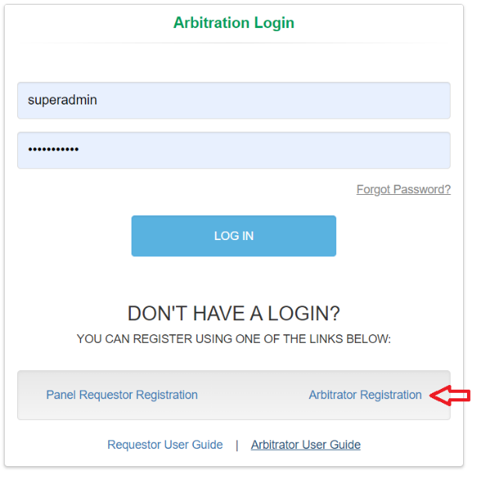
- On the Register Arbitrator window enter the required information, check “I’m not a robot” checkbox and click Register.
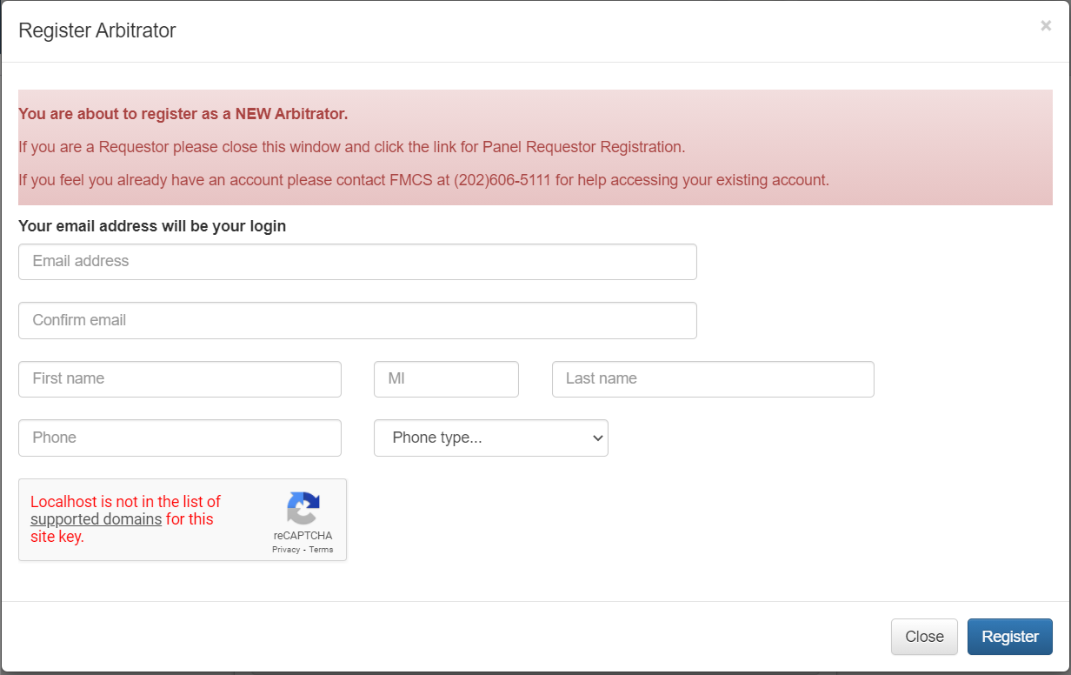
- A temporary password will be emailed to you at the email supplied during the registration process.
- When you login for the first time, you will be required to change your password.

LOGIN
To login to the arbitration system, you must already be a registered user.
- Enter your username and password on the login page and click the LOG IN button.
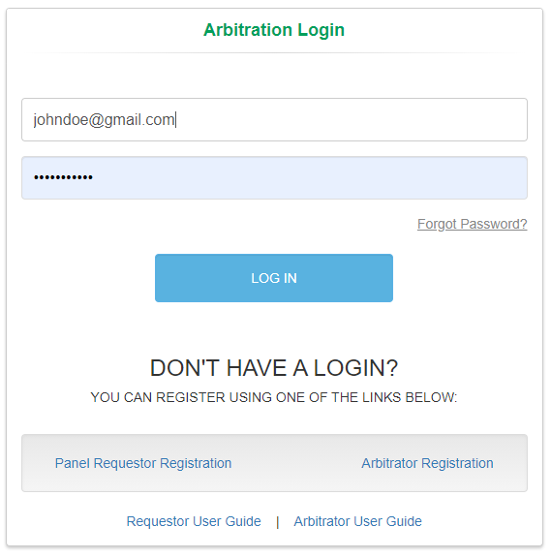
- If you have forgotten your password, click the Forgot Password Link on the login page. An email will be sent to the email address you enter with a new temporary password.
- When you login for the first time, you will be required to change your password.
- If you have any issues trying to log into the system or if you have already registered but do not remember your username, contact the FMCS Arbitration Staff at (202) 606-5111.
- If you have already submitted your application and been accepted onto the roster, please see the Arbitrator User Manual for further details.

LOGOUT
To logout of the arbitration system, you should click the Logout button found at the top right of your screen. Clicking this button will help the system track when you have left.
The system will also automatically log you out after 20 minutes of inactivity. When this happens, you will be returned to the login page where a message will display saying that you have automatically been logged out due to inactivity.
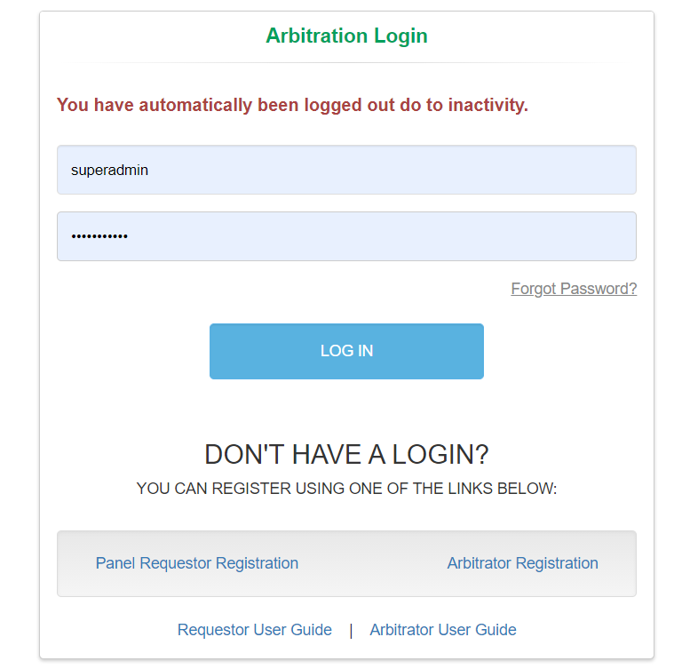

HOME

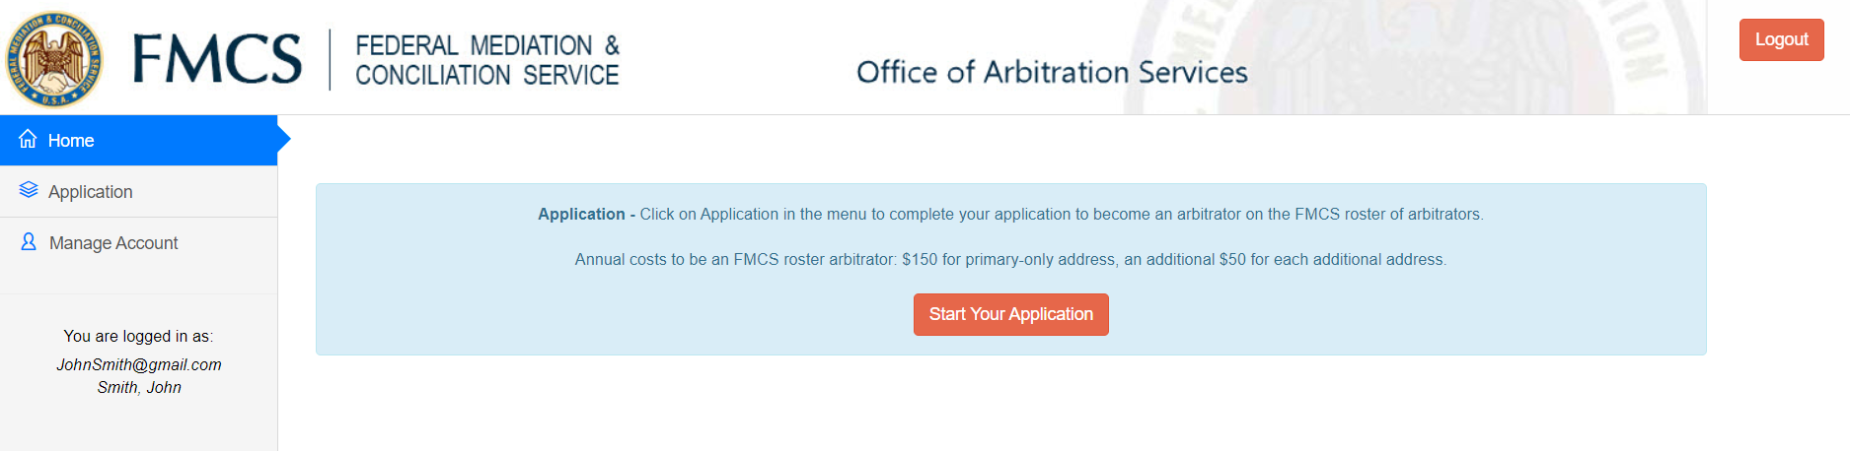
- Click Home in the left navigation menu. This will also be your default screen upon login.
- Click the Start Your Application/Continue Your Application button.
- The Application process consists of 10 steps. Enter all required information and any optional information you would like included on your digital biography once you are accepted to the roster. You will be able to view and make changes to this information after being accepted to the roster.
- Once submitted you will no longer be able to access your application. Your home page will show the following message until you have been accepted to the roster.

APPLICATION
- Click Application in the left navigation menu. This will walk you through the 10 Steps of the application process.
- As you complete a step your information is saved. Should you leave and come back all your information will still be there however you will need to click next through each step to continue.

STEP 1: Biographical Information
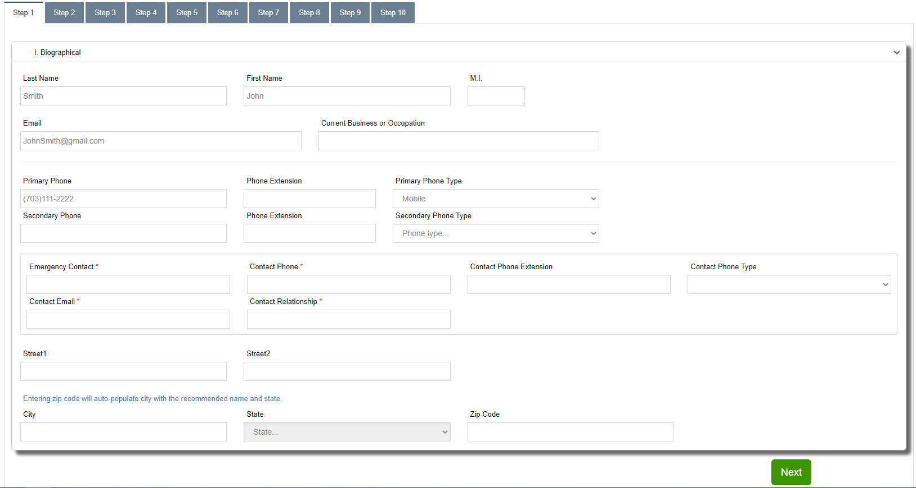
- Your Name, Email and Phone will default to the values you entered when registering for the site.
- Emergency contact fields are required.
- Primary Address is required. If you enter the zip code the city and state will automatically get populated
- Click the Next button when you are done entering the required information.

STEP 2: Education, Certifications, and Professional Memberships.
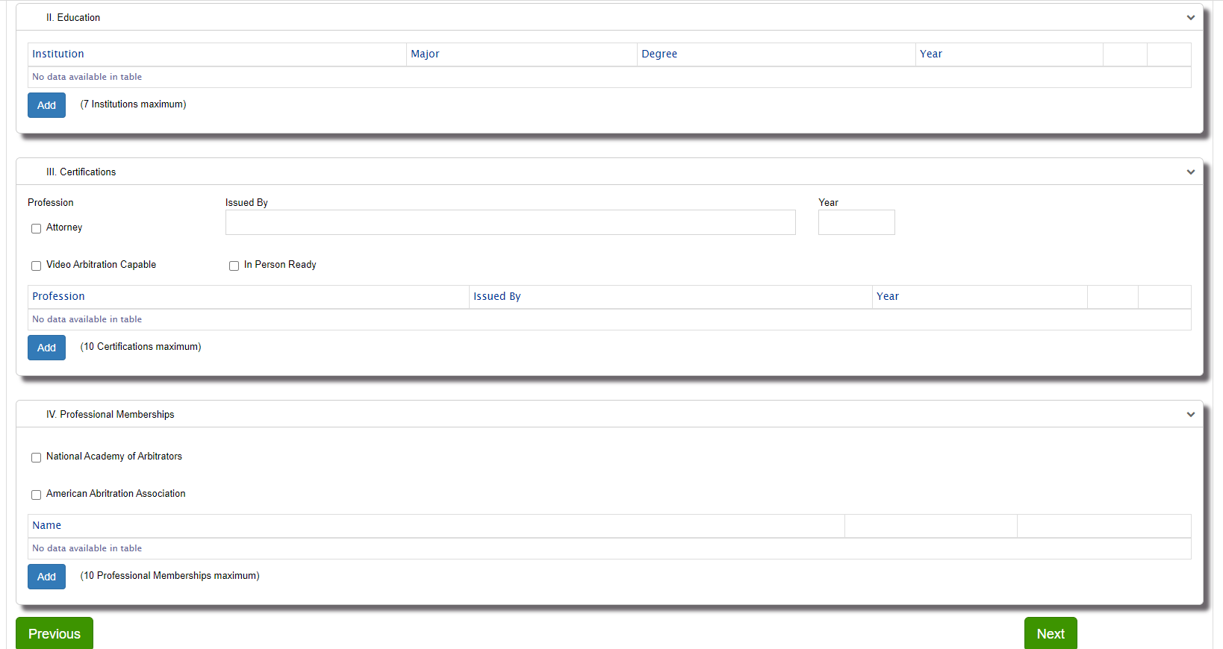
- These sections are all optional and are filled out in a similar manner.
- To Add new values, click the Add button. Depending on the button clicked one of the following windows will open. Fill out the required information and click the Save button. The information you entered will now display in the table.
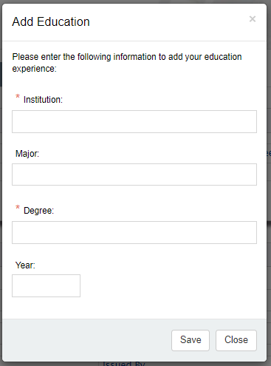 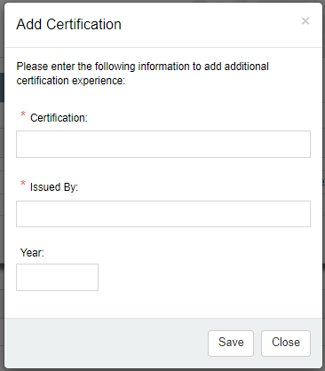 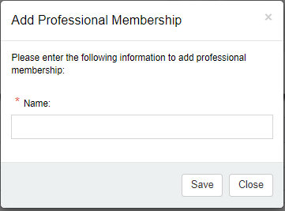
- To Edit an existing value click the pen on the right. A window will open with the current values so that you can make updates. Click the Update button
- To Delete an existing value click the x on the right. An alert will display asking you if you are sure you want to delete the information.
- Click the Previous button if you need to return to the prior step.
- Click the Next button when you are done entering the required information.

STEP 3: Labor-Management Relations Experience, Union Involvement and Government positions
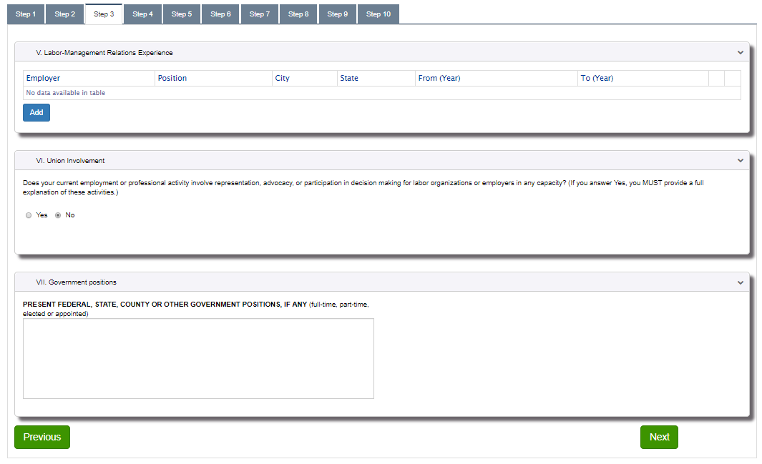
- These sections are all optional and are filled out in a similar manner as you did in the prior step.
- To Add new values, click the Add button. The following windows will open. Fill out the required information and click the Save button. The information you entered will now display in the table.
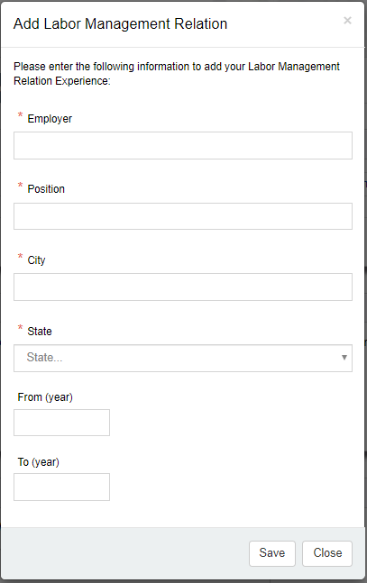
- To Edit an existing value click the pen on the right. A window will open with the current values so that you can make updates. Click the Update button
- To Delete an existing value click the x on the right. An alert will display asking you if you are sure you want to delete the information.
- Click the Previous button if you need to return to the prior step.
- Click the Next button when you are done entering the required information.

STEP 4: Permanent Panels and Arbitration Rosters
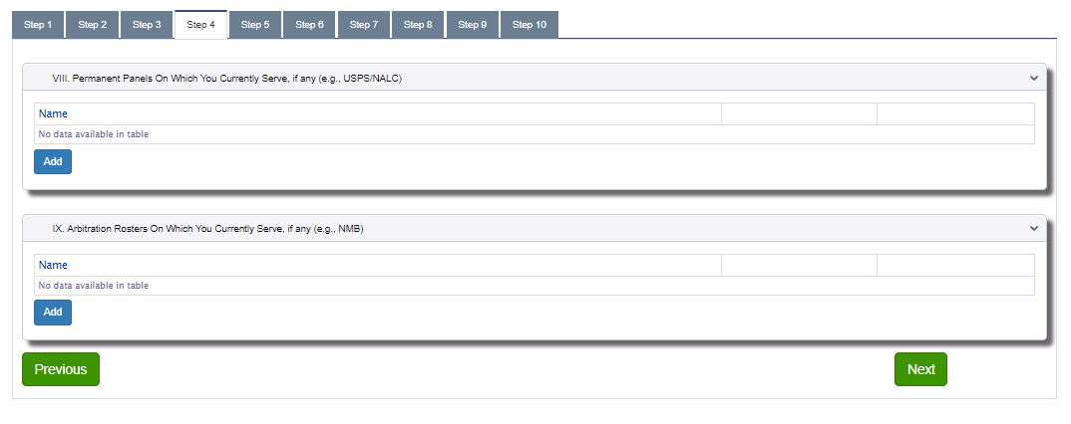
- These sections are all optional and are filled out in a similar manner.
- To Add new values, click the Add button. Depending on the button clicked one of the following windows will open. Fill out the required information and click the Save button. The information you entered will now display in the table.
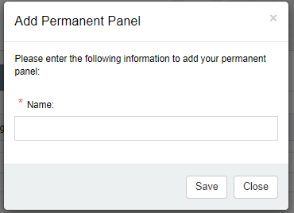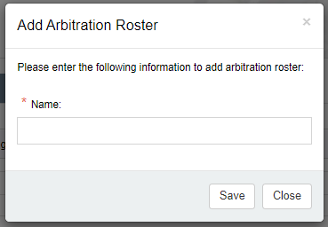
- To Edit an existing value click the pen on the right. A window will open with the current values so that you can make updates. Click the Update button
- To Delete an existing value click the x on the right. An alert will display asking you if you are sure you want to delete the information.
- Click the Previous button if you need to return to the prior step.
- Click the Next button when you are done entering the required information.

STEP 5: Issue Experience
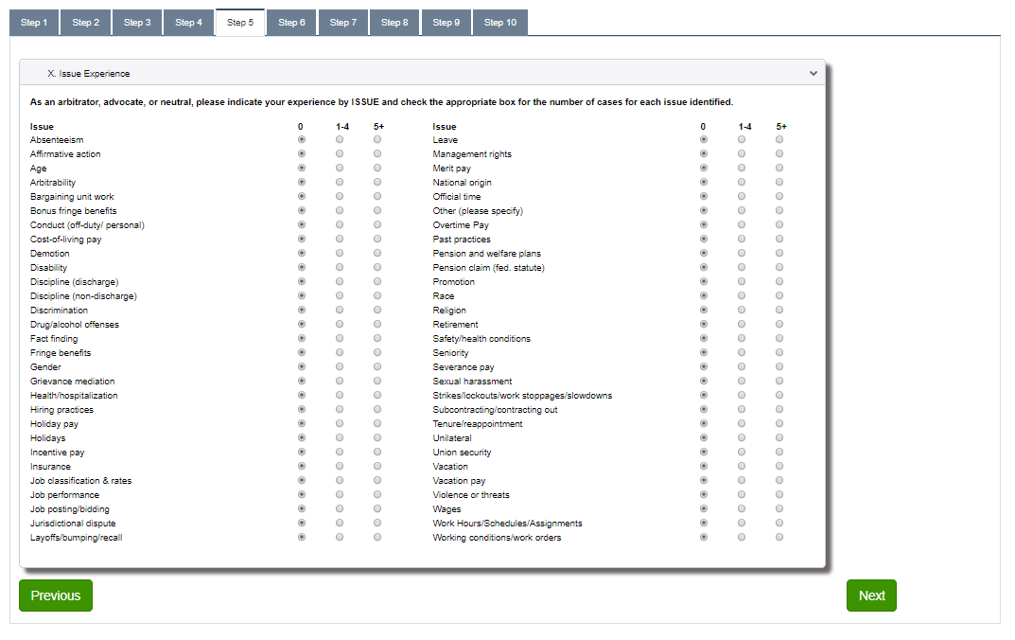
- All issues are defaulted to 0. Only issues where you say you have 1-4 or 5+ years will be included on your digital biography once you are accepted to the roster. You will be able to view and make changes to this information after being accepted to the roster.
- Click the Previous button if you need to return to the prior step.
- Click the Next button when you are done entering the required information.

STEP 6: Industry Experience
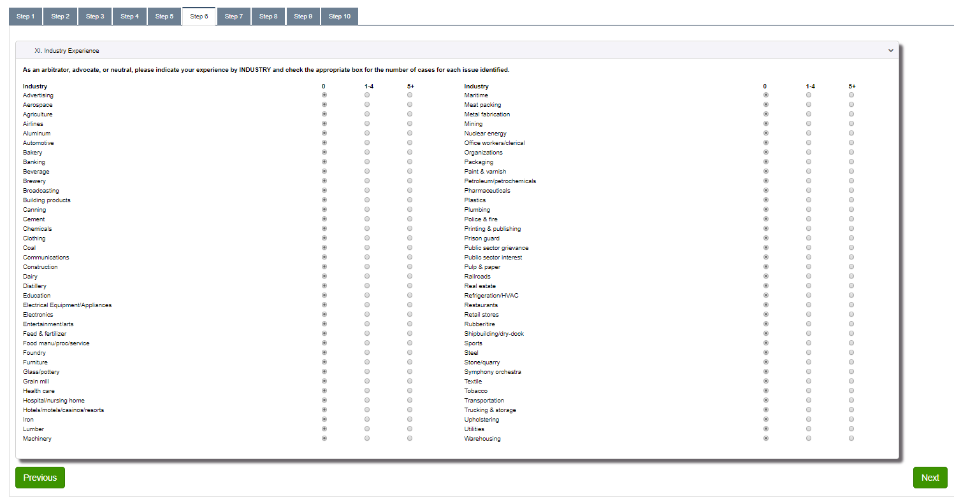
- All Industries are defaulted to 0. Only Industries where you say you have 1-4 or 5+ years will be included on your digital biography once you are accepted to the roster. You will be able to view and make changes to this information after being accepted to the roster.
- Click the Previous button if you need to return to the prior step.
- Click the Next button when you are done entering the required information.

STEP 7: Sector Experience, Registration, Language Proficiency and Arbitration Experience
Enter your Sector Experience, Registration, Language Proficiency and Arbitration Experience
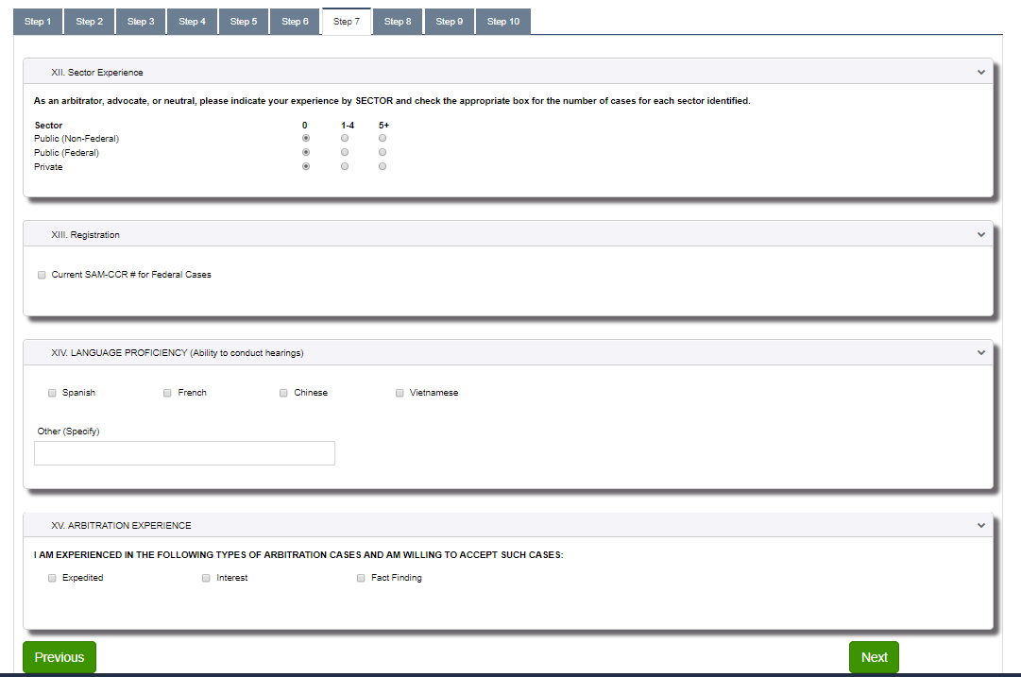
- These sections are all optional.
- All Sectors are defaulted to 0 cases.
- Click the Previous button if you need to return to the prior step.
- Click the Next button when you are done entering the required information.

STEP 8: Federal Sector Experience and Fees Charged
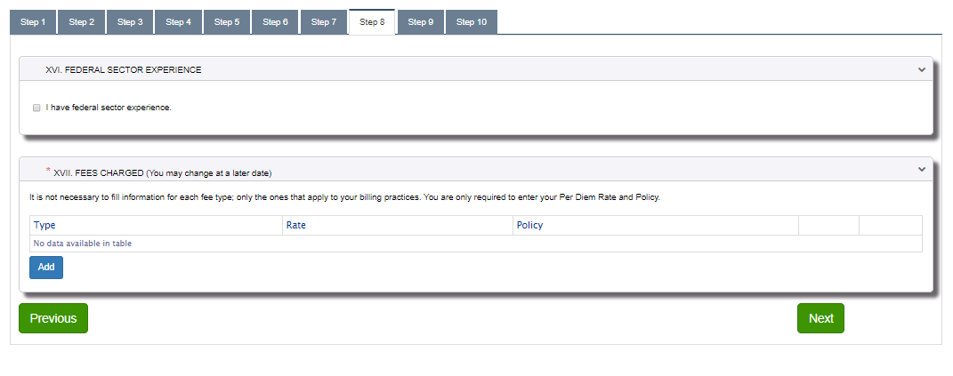
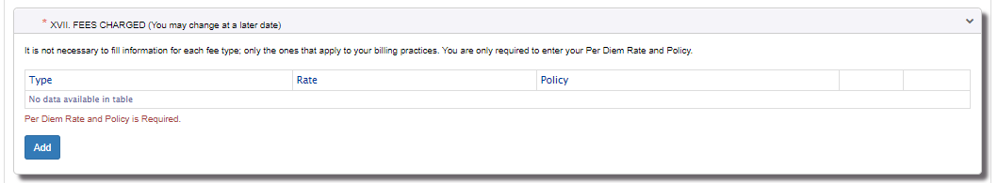
- Per Diem Fee is the only required value on this Step. You will not be able to go to the next step until you have added a per diem fee. All other fees can be optionally added.
- To Add new fee, click the Add button. Fill out the required information and click the Save button. The information you entered will now display in the table.
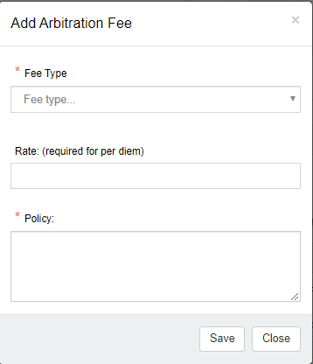
- To Edit an existing value click the pen on the right. A window will open with the current values so that you can make updates. Click the Update button
- To Delete an existing value click the x on the right. An alert will display asking you if you are sure you want to delete the information.
- Click the Previous button if you need to return to the prior step.
- Click the Next button when you are done entering the required information.

STEP 9: Award Citations, Publications and Date Available
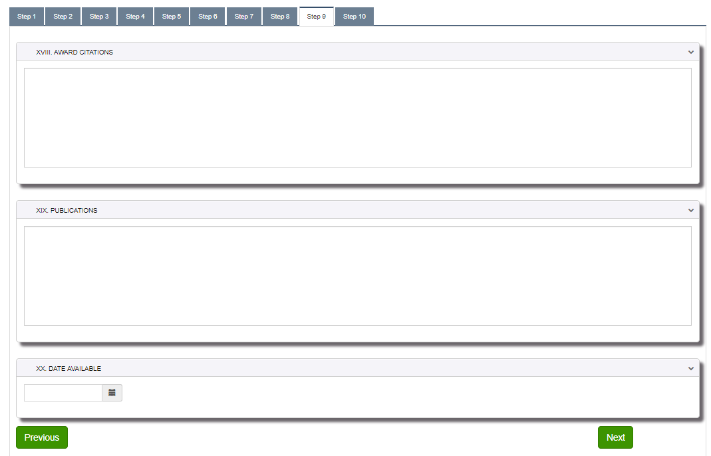
- These sections are all optional.
- Publications are limited to 1500 characters. Once you have reached the 1500th character you will no longer be able to type. It is recommended that you enter your most recent or most relevant published cases. You may also look for ways to abbreviate should you have more than 1500 characters.
- Click the Previous button if you need to return to the prior step.
- Click the Next button when you are done entering the required information.

STEP 10: Certification of Advocacy and Accuracy of Information
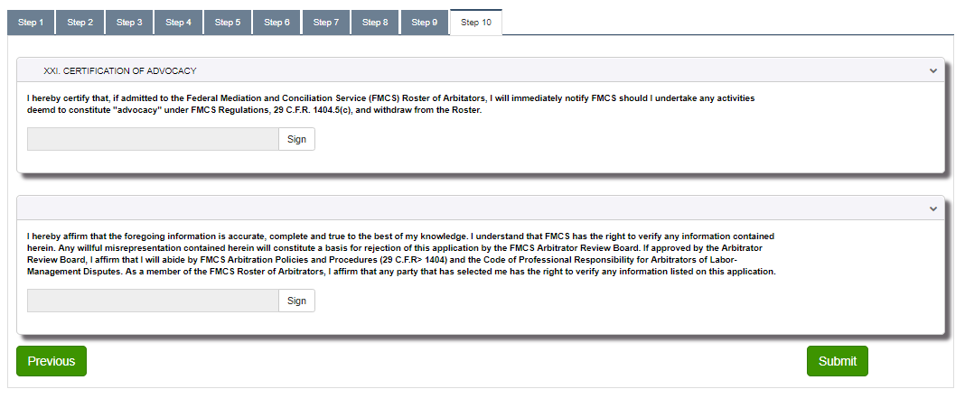
- These signatures are required before you can submit your application. Click the Sign button after reading the information provided for each section.
- Click the Previous button if you need to return to the prior step.
- Click the Submit button when you are ready to submit your application. You will see the following message until you have been accepted to the roster. Once accepted please following the Arbitrator User Guide.
- The FMCS Arbitration Staff will receive and email that your application has been submitted and is awaiting acceptance to the roster.

MANAGE ACCOUNT
You can manage your account via Manage Account on the left navigation menu.
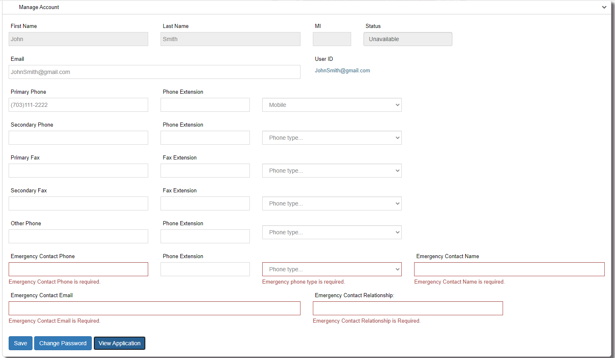
- Click on the Manage Account link the left navigation menu.
- Make all necessary changes to your account information and click the Save button. Emergency Contact information fields are required. Changes to your email address will only change your email. Your current login will remain the same. Should you like your login to be synced up with your new email you will need to contact the FMCS Arbitration Staff at (202) 606-5111 and ask them to sync up your login with your new email.
- To change your password, click on the Change Password button. Enter your new password and click Submit button.
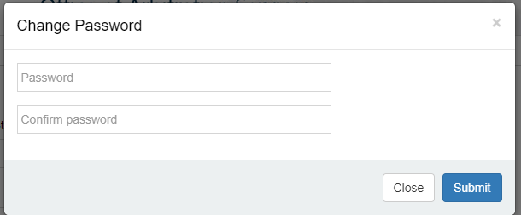
- To view your application, click on the View Application button. Form R-22 will be populated with all the information you have entered for you application.

FAQs

I registered for a new account or I clicked Forgot my password, but I did not receive an email.
Check your Junk/Spam folder. If you are running anti-virus, check your quarantine folder. Contact your IT department to investigate spam filters and/or firewalls to see if the email was identified as span and thus never delivered. Contact the FMCS Arbitration Staff at (202) 606-5111 to confirm that you have the correct email address in the system and if they can confirm if the email was sent or bounced back.

My email address has changed; I am no longer able to log into the system or I would prefer to log in using my new email address.
The system is still using your old email address as its login. You should log in with your old email address and then go to Manage Accounts where you can update your email. This will change only your email so that you will receive all necessary correspondence. Your login would remain as your old email. Should you like your login to be synced up with your new email you will need to contact the FMCS Arbitration Staff at (202) 606-5111 and ask them to sync up your login with your new email. It is important that you do not create a new account with your new email address. Doing so would require you to fill out and submit a new application to be accepted to the roster.

If you have already created a new account do not worry, contact the FMCS Arbitration Staff at (202) 606-5111. They can remove the new account and help you regain access to your original account.

I need to update my application, but I have already submitted it.
If the information is relevant to your acceptance to the roster, contact the FMCS Arbitration Staff at (202) 606-5111 and ask them if they can return your application to you. Once they return it you can navigate though the 10 steps and submit the application again.

If the information is not relevant to your acceptance to the roster once you are accepted your application data will become part of your digital biography. As an arbitrator on the roster, you will have access to update your biography information at any time.

